**類比積體電路實習心得報告:**

**班級:電子三甲**

**姓名:李仲崴**

**學號:108360133**

1. **心得:**

**一開始我以為類比積體電路設計就是接電路而已，並沒有什麼需要動腦的地方；但等到開始學習時，才發現原來是用程式來模擬電路，第一堂課時發現是打程式還以為會很難。等到接觸時才發現是用程式描述要模擬的電路長相，並沒有很困難；而且只要打城市去模擬，並不用花很多時間去接電路。**

**LAB1:**

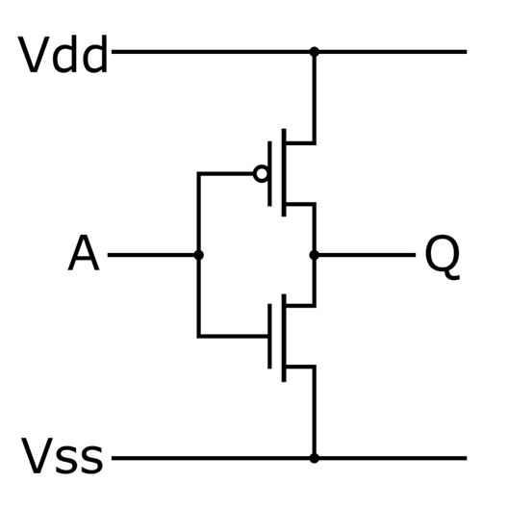

1: ***inv***

.lib './cic018.l'tt

.SUBCKT INV 10 20 100 99

M1 20 10 100 100 P_18 W=10U L=0.2U

M2 20 10 99 99 N_18 W=5U L=0.2U

.ENDS INV

Vdd 100 0 dc 1.8V

X1 1 2 100 0 INV

*Vin 1 0 dc 0.84V ac 1V pulse(0V 1.8V 0.5us 0 0 0.5us 1us)

Vin 1 0 dc 0.84V ac 1V sin(0.84V 1mV 1000k)

**analysis

.op

.option post

.dc Vin 0 1.8 0.001

*.ac dec 50 1 1G

*.tran 1ns 10us 0 10ns

.probe

.end

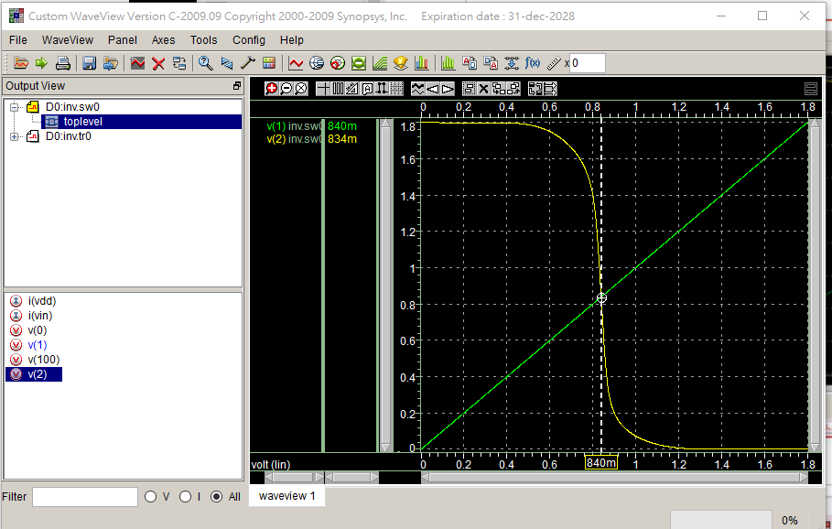

2.

***inv***

.lib './cic018.l'tt

.SUBCKT INV 10 20 100 99

M1 20 10 100 100 P_18 W=10U L=0.2U

M2 20 10 99 99 N_18 W=5U L=0.2U

.ENDS INV

Vdd 100 0 dc 1.8V

X1 1 2 100 0 INV

*Vin 1 0 dc 0.84V ac 1V pulse(0V 1.8V 0.5us 0 0 0.5us 1us)

Vin 1 0 dc 0.84V ac 1V sin(0.84V 1mV 1000k)

**analysis

.op

.option post

*.dc Vin 0 1.8 0.001

.ac dec 50 1 10G

*.tran 1ns 10us 0 10ns

.probe

.end

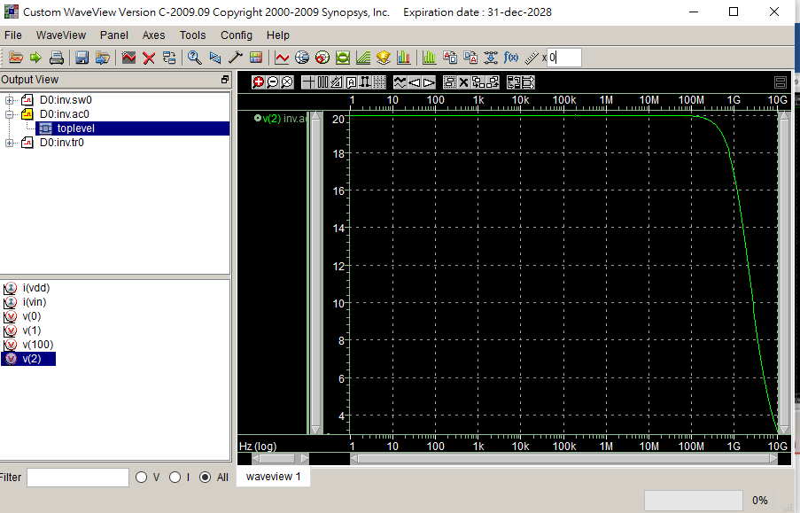

3.

***inv***

.lib './cic018.l'tt

.SUBCKT INV 10 20 100 99

M1 20 10 100 100 P_18 W=10U L=0.2U

M2 20 10 99 99 N_18 W=5U L=0.2U

.ENDS INV

Vdd 100 0 dc 1.8V

X1 1 2 100 0 INV

*Vin 1 0 dc 0.84V ac 1V pulse(0V 1.8V 0.5us 0 0 0.5us 1us)

Vin 1 0 dc 0.84V ac 1V sin(0.84V 1mV 1000k)

**analysis

.op

.option post

*.dc Vin 0 1.8 0.001

*.ac dec 50 1 10G

.tran 1ns 10us 0 10ns

.probe

.end

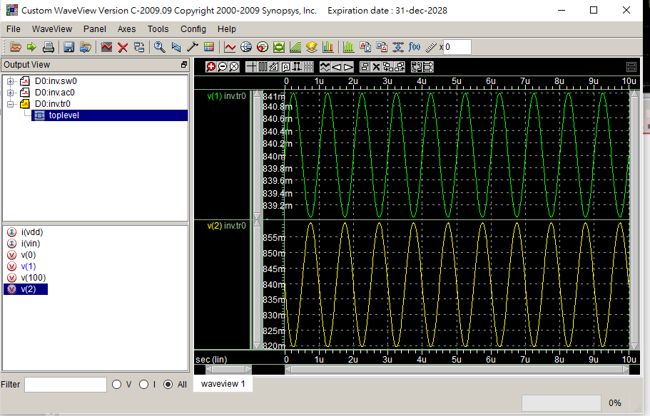

4.

***inv***

.lib './cic018.l'tt

.SUBCKT INV 10 20 100 99

M1 20 10 100 100 P_18 W=10U L=0.2U

M2 20 10 99 99 N_18 W=5U L=0.2U

.ENDS INV

Vdd 100 0 dc 1.8V

X1 1 2 100 0 INV

Vin 1 0 dc 0.84V ac 1V pulse(0V 1.8V 0.5us 0 0 0.5us 1us)

*Vin 1 0 dc 0.84V ac 1V sin(0.84V 1mV 1000k)

**analysis

.op

.option post

*.dc Vin 0 1.8 0.001

*.ac dec 50 1 10G

.tran 1ns 10us 0 10ns

.probe

.end

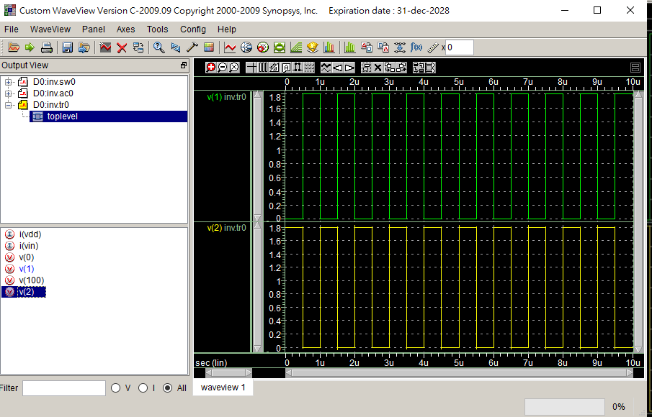

5.

***inv***

.lib './cic018.l'tt

.SUBCKT INV 10 20 100 99

M1 20 10 100 100 P_18 W=10U L=0.2U

M2 20 10 99 99 N_18 W=5U L=0.2U

.ENDS INV

Vdd 100 0 dc 1.8V

X1 1 2 100 0 INV

*Vin 1 0 dc 0.84V ac 1V pulse(0V 1.8V 0.5us 0 0 0.5us 1us)

Vin 1 0 dc 0.84V ac 1V pulse(0V 1.8V 0.5ns 0 0 0.5ns 1ns)

*Vin 1 0 dc 0.84V ac 1V sin(0.84V 1mV 1000k)

**analysis

.op

.option post

*.dc Vin 0 1.8 0.001

*.ac dec 50 1 10G

*.tran 1ns 10us 0 10ns

.tran 1ps 10ns 0 10ps

.probe Vp(2)

.end

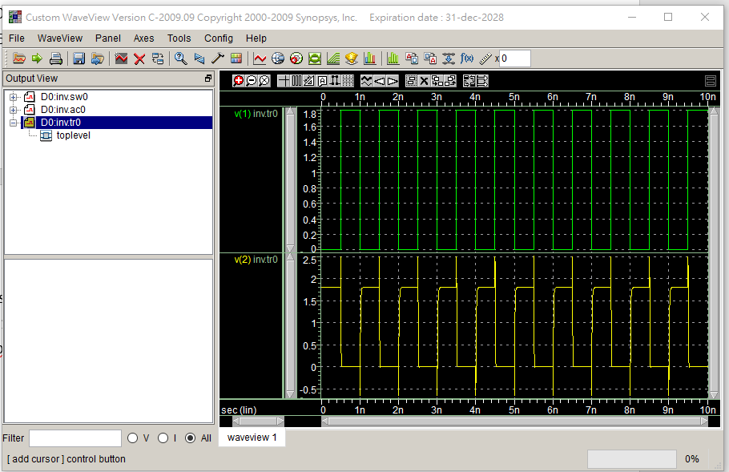

6.

ROSC

.lib './cic018.l'tt

.SUBCKT INV 10 20 100 99

M1 20 10 100 100 P_18 W=2U L=2U

M2 20 10 99 99 N_18 W=1U L=2U

.ENDS INV

Vdd 100 0 dc PWL(0ps 0 1us 0 1.1us 1.8V 2us 1.8V))

X1 1 2 100 0 INV

X2 2 3 100 0 INV

X3 3 4 100 0 INV

X4 4 5 100 0 INV

X5 5 1 100 0 INV

**analysis

.op

.option post

.tran 1ps 10us 0 0.1ns

.probe

.end

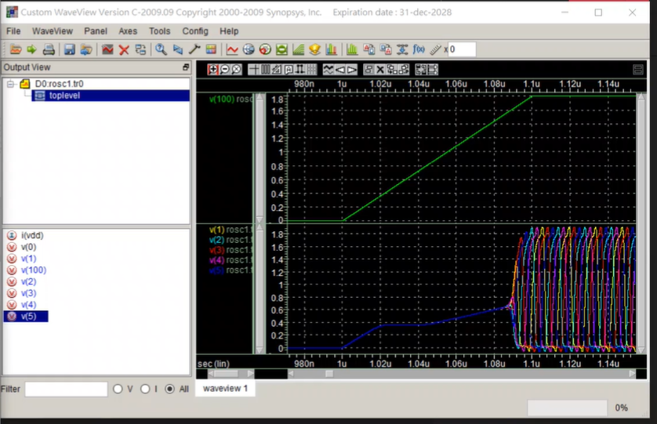

LAB6

2u

ROSC

.lib 'C:\users\user\sp\cic018.l' tt

.SUBCKT INV 10 20 100 99

M1 20 10 100 100 P_18 W=10U L=2U

M2 20 10 99 99 N_18 W=5U L=2U

.ENDS INV

.SUBCKT NAND A B Y 100 99

M1 Y A 100 100 P_18 W=1U L=2U

M2 Y B 100 100 P_18 W=1U L=2U

M3 Y B 1 99 N_18 W=2U L=2U

M4 1 A 99 99 N_18 W=21U L=2U

.ENDS NAND

.SUBCKT NOR A B Y 100 99

M1 1 A 100 100 P_18 W=2U L=2U

M2 Y B 1 100 P_18 W=2U L=2U

M3 Y A 99 99 N_18 W=1U L=2U

M4 Y B 99 99 N_18 W=1U L=2U

.ENDS NOR

Vdd 100 0 dc PWL(0 0 1us 0 1.1us 1.8V 2us 1.8V)

*X1 1 2 100 0 INV

*X2 2 3 100 0 INV

*X3 3 4 100 0 INV

*X4 4 5 100 0 INV

*X5 5 1 100 0 INV

X1 1 1 2 100 0 NAND

X2 2 2 3 100 0 NAND

X3 3 3 4 100 0 NAND

X4 4 4 5 100 0 NAND

X5 5 5 1 100 0 NAND

*X1 1 1 2 100 0 NOR

*X2 2 2 3 100 0 NOR

*X3 3 3 4 100 0 NOR

*X4 4 4 5 100 0 NOR

*X5 5 5 1 100 0 NOR

**analysis

.op

.option post

.tran 1ps 10us 0 0.1ns

.probe

.end

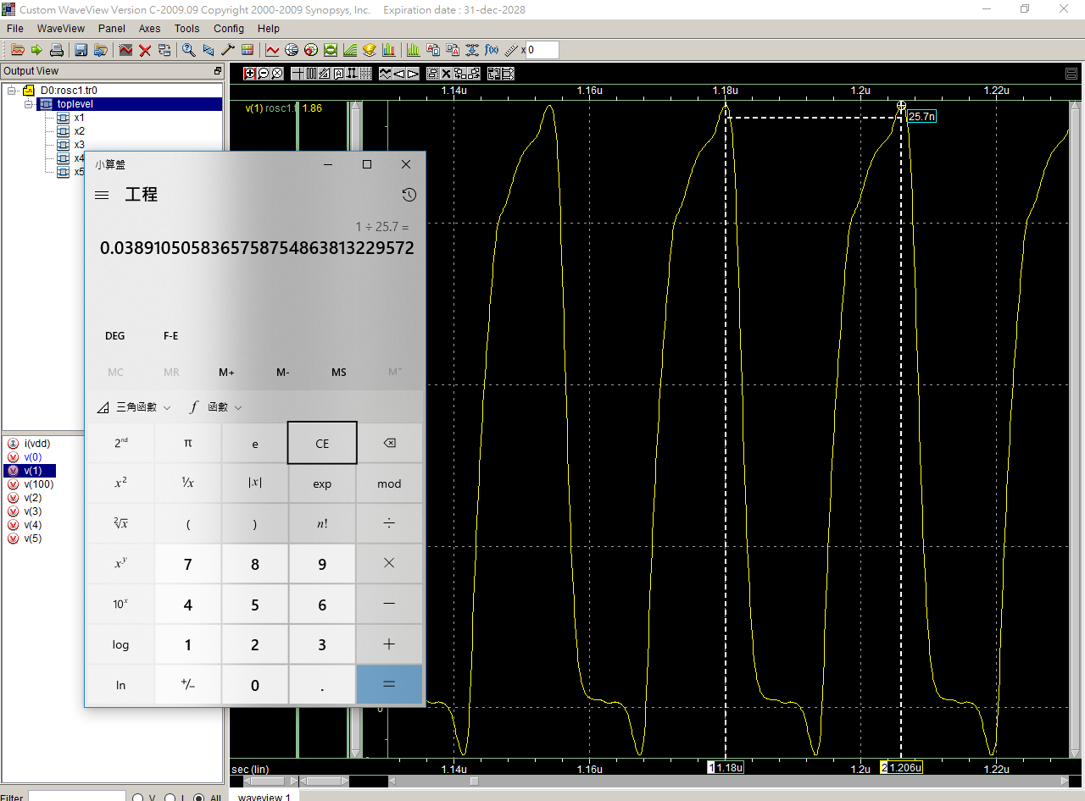

3u

ROSC

.lib 'C:\users\user\sp\cic018.l' tt

.SUBCKT INV 10 20 100 99

M1 20 10 100 100 P_18 W=10U L=2U

M2 20 10 99 99 N_18 W=5U L=2U

.ENDS INV

.SUBCKT NAND A B Y 100 99

M1 Y A 100 100 P_18 W=1U L=3U

M2 Y B 100 100 P_18 W=1U L=3U

M3 Y B 1 99 N_18 W=2U L=3U

M4 1 A 99 99 N_18 W=2U L=3U

.ENDS NAND

.SUBCKT NOR A B Y 100 99

M1 1 A 100 100 P_18 W=2U L=2U

M2 Y B 1 100 P_18 W=2U L=2U

M3 Y A 99 99 N_18 W=1U L=2U

M4 Y B 99 99 N_18 W=1U L=2U

.ENDS NOR

Vdd 100 0 dc PWL(0 0 1us 0 1.1us 1.8V 2us 1.8V)

*X1 1 2 100 0 INV

*X2 2 3 100 0 INV

*X3 3 4 100 0 INV

*X4 4 5 100 0 INV

*X5 5 1 100 0 INV

X1 1 1 2 100 0 NAND

X2 2 2 3 100 0 NAND

X3 3 3 4 100 0 NAND

X4 4 4 5 100 0 NAND

X5 5 5 1 100 0 NAND

*X1 1 1 2 100 0 NOR

*X2 2 2 3 100 0 NOR

*X3 3 3 4 100 0 NOR

*X4 4 4 5 100 0 NOR

*X5 5 5 1 100 0 NOR

**analysis

.op

.option post

.tran 1ps 10us 0 0.1ns

.probe

.end

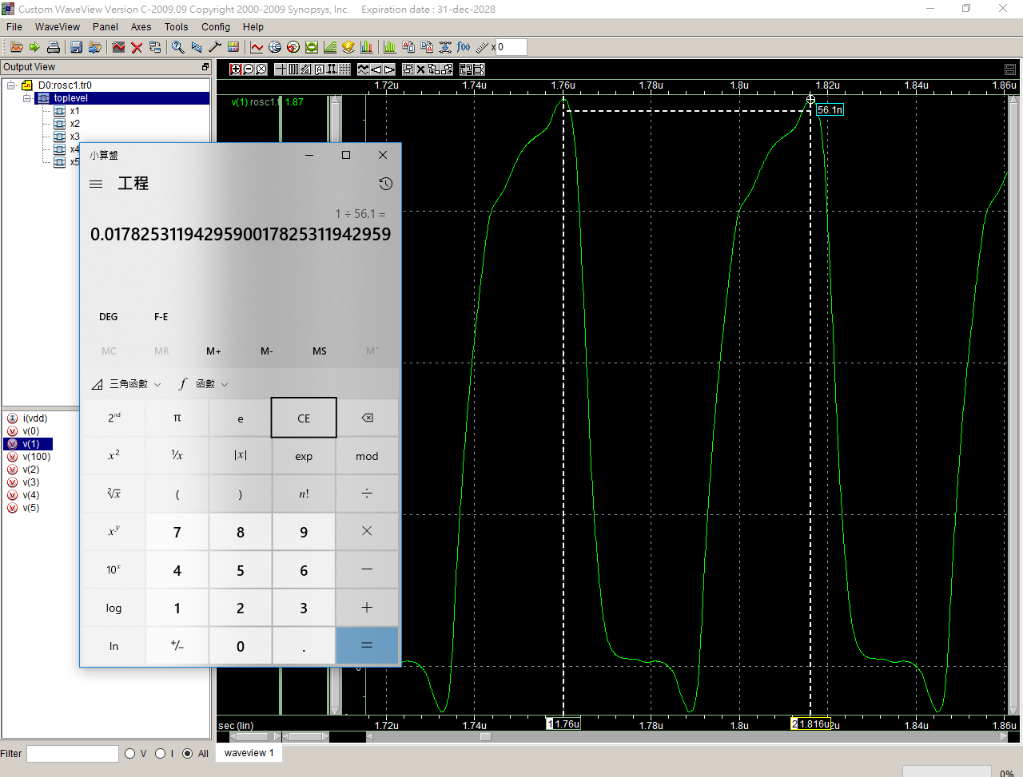

4u

ROSC

.lib 'C:\users\user\sp\cic018.l' tt

.SUBCKT INV 10 20 100 99

M1 20 10 100 100 P_18 W=10U L=2U

M2 20 10 99 99 N_18 W=5U L=2U

.ENDS INV

.SUBCKT NAND A B Y 100 99

M1 Y A 100 100 P_18 W=1U L=4U

M2 Y B 100 100 P_18 W=1U L=4U

M3 Y B 1 99 N_18 W=2U L=4U

M4 1 A 99 99 N_18 W=2U L=4U

.ENDS NAND

.SUBCKT NOR A B Y 100 99

M1 1 A 100 100 P_18 W=2U L=2U

M2 Y B 1 100 P_18 W=2U L=2U

M3 Y A 99 99 N_18 W=1U L=2U

M4 Y B 99 99 N_18 W=1U L=2U

.ENDS NOR

Vdd 100 0 dc PWL(0 0 1us 0 1.1us 1.8V 2us 1.8V)

*X1 1 2 100 0 INV

*X2 2 3 100 0 INV

*X3 3 4 100 0 INV

*X4 4 5 100 0 INV

*X5 5 1 100 0 INV

X1 1 1 2 100 0 NAND

X2 2 2 3 100 0 NAND

X3 3 3 4 100 0 NAND

X4 4 4 5 100 0 NAND

X5 5 5 1 100 0 NAND

*X1 1 1 2 100 0 NOR

*X2 2 2 3 100 0 NOR

*X3 3 3 4 100 0 NOR

*X4 4 4 5 100 0 NOR

*X5 5 5 1 100 0 NOR

**analysis

.op

.option post

.tran 1ps 10us 0 0.1ns

.probe

.end

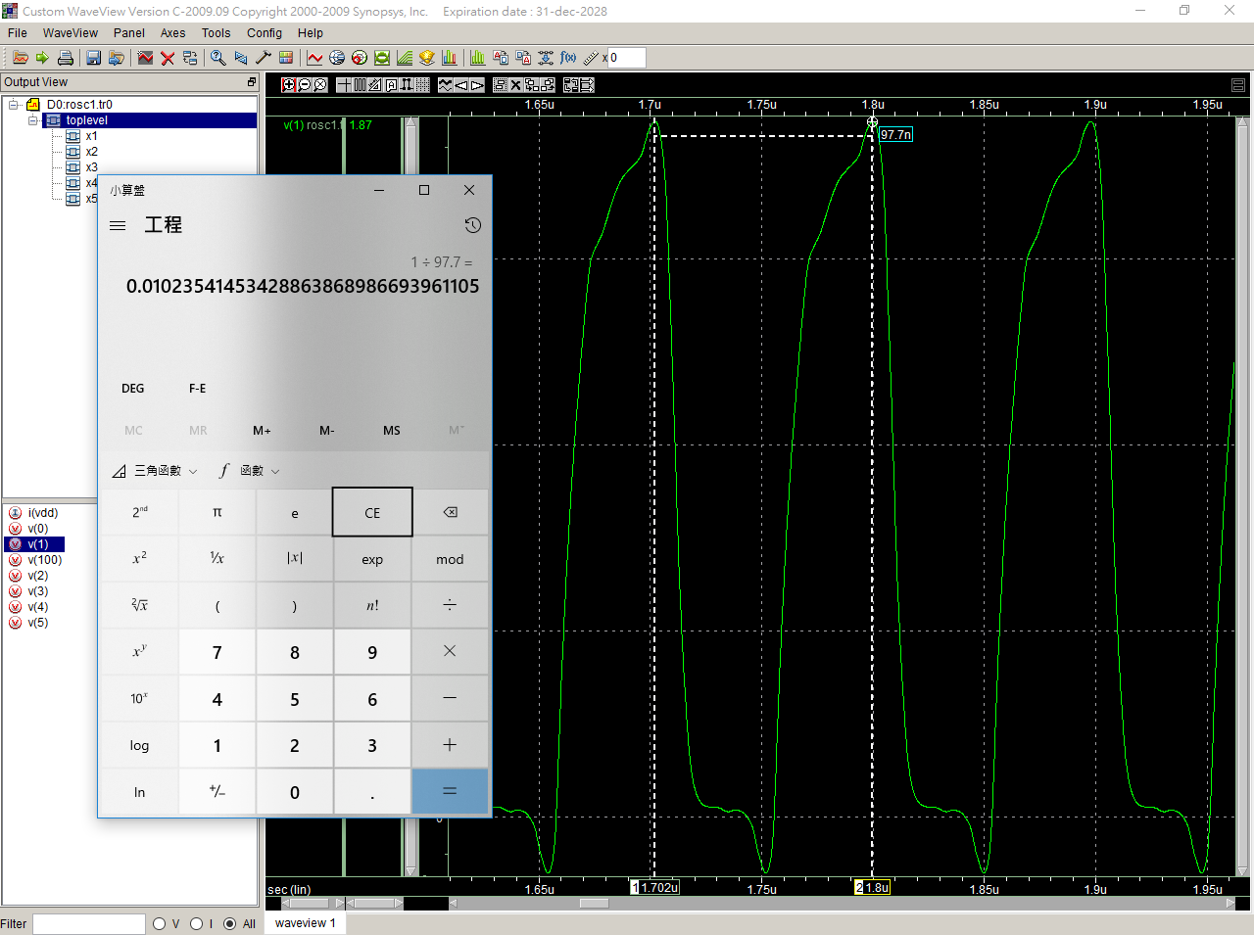

5u

ROSC

.lib 'C:\users\user\sp\cic018.l' tt

.SUBCKT INV 10 20 100 99

M1 20 10 100 100 P_18 W=10U L=2U

M2 20 10 99 99 N_18 W=5U L=2U

.ENDS INV

.SUBCKT NAND A B Y 100 99

M1 Y A 100 100 P_18 W=1U L=5U

M2 Y B 100 100 P_18 W=1U L=5U

M3 Y B 1 99 N_18 W=2U L=5U

M4 1 A 99 99 N_18 W=2U L=5U

.ENDS NAND

.SUBCKT NOR A B Y 100 99

M1 1 A 100 100 P_18 W=2U L=2U

M2 Y B 1 100 P_18 W=2U L=2U

M3 Y A 99 99 N_18 W=1U L=2U

M4 Y B 99 99 N_18 W=1U L=2U

.ENDS NOR

Vdd 100 0 dc PWL(0 0 1us 0 1.1us 1.8V 2us 1.8V)

*X1 1 2 100 0 INV

*X2 2 3 100 0 INV

*X3 3 4 100 0 INV

*X4 4 5 100 0 INV

*X5 5 1 100 0 INV

X1 1 1 2 100 0 NAND

X2 2 2 3 100 0 NAND

X3 3 3 4 100 0 NAND

X4 4 4 5 100 0 NAND

X5 5 5 1 100 0 NAND

*X1 1 1 2 100 0 NOR

*X2 2 2 3 100 0 NOR

*X3 3 3 4 100 0 NOR

*X4 4 4 5 100 0 NOR

*X5 5 5 1 100 0 NOR

**analysis

.op

.option post

.tran 1ps 10us 0 0.1ns

.probe

.end

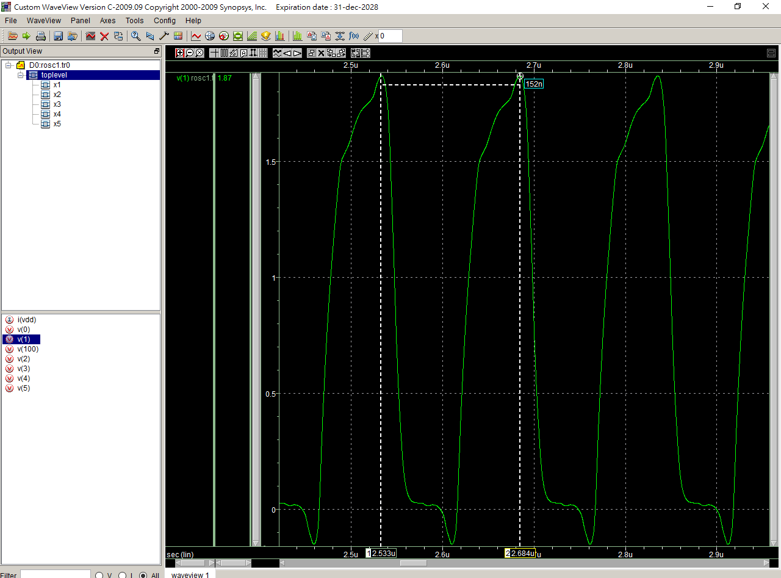

6u

ROSC

.lib 'C:\users\user\sp\cic018.l' tt

.SUBCKT INV 10 20 100 99

M1 20 10 100 100 P_18 W=10U L=2U

M2 20 10 99 99 N_18 W=5U L=2U

.ENDS INV

.SUBCKT NAND A B Y 100 99

M1 Y A 100 100 P_18 W=1U L=6U

M2 Y B 100 100 P_18 W=1U L=6U

M3 Y B 1 99 N_18 W=2U L=6U

M4 1 A 99 99 N_18 W=2U L=6U

.ENDS NAND

.SUBCKT NOR A B Y 100 99

M1 1 A 100 100 P_18 W=2U L=2U

M2 Y B 1 100 P_18 W=2U L=2U

M3 Y A 99 99 N_18 W=1U L=2U

M4 Y B 99 99 N_18 W=1U L=2U

.ENDS NOR

Vdd 100 0 dc PWL(0 0 1us 0 1.1us 1.8V 2us 1.8V)

*X1 1 2 100 0 INV

*X2 2 3 100 0 INV

*X3 3 4 100 0 INV

*X4 4 5 100 0 INV

*X5 5 1 100 0 INV

X1 1 1 2 100 0 NAND

X2 2 2 3 100 0 NAND

X3 3 3 4 100 0 NAND

X4 4 4 5 100 0 NAND

X5 5 5 1 100 0 NAND

*X1 1 1 2 100 0 NOR

*X2 2 2 3 100 0 NOR

*X3 3 3 4 100 0 NOR

*X4 4 4 5 100 0 NOR

*X5 5 5 1 100 0 NOR

**analysis

.op

.option post

.tran 1ps 10us 0 0.1ns

.probe

.end

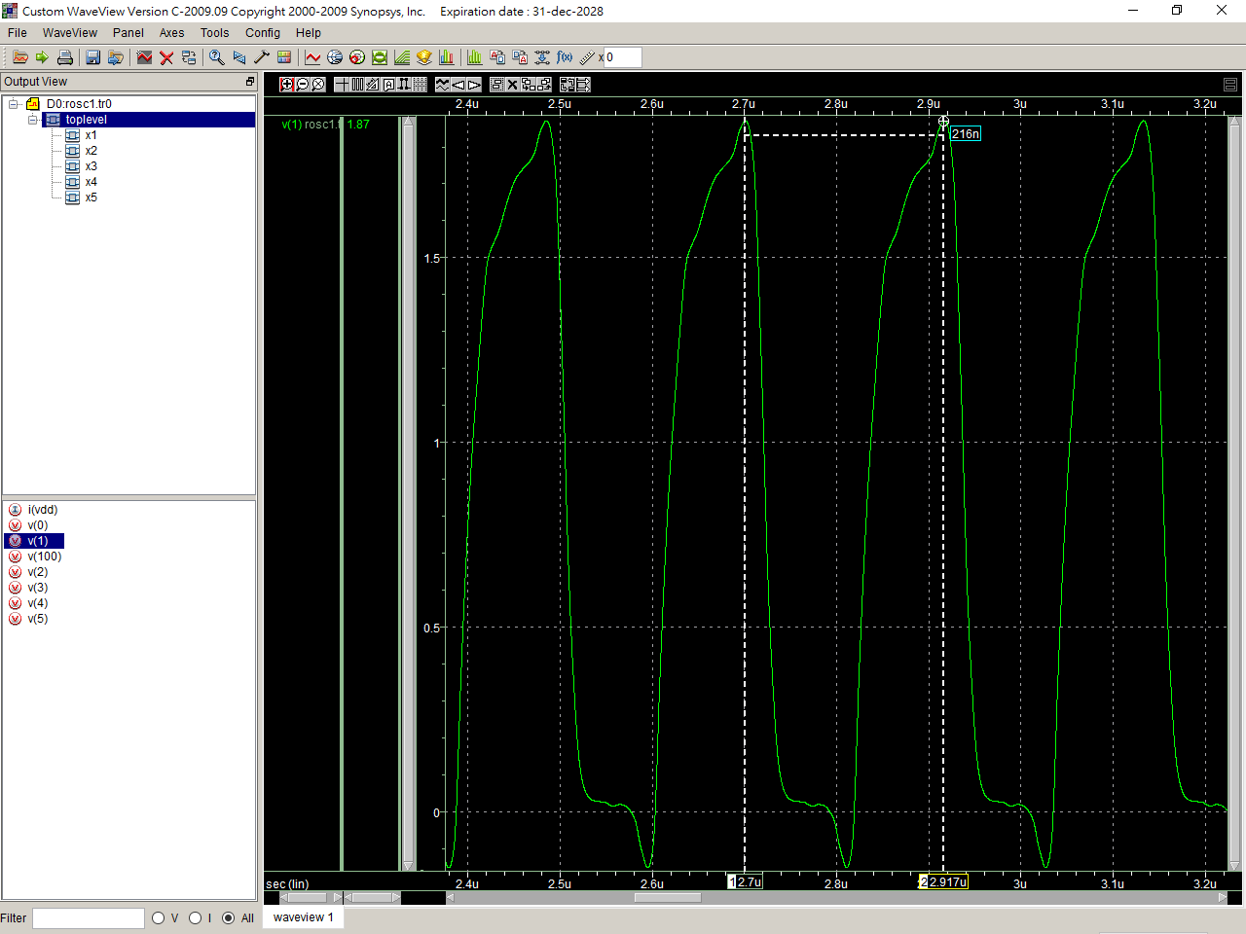

7u

ROSC

.lib 'C:\users\user\sp\cic018.l' tt

.SUBCKT INV 10 20 100 99

M1 20 10 100 100 P_18 W=10U L=2U

M2 20 10 99 99 N_18 W=5U L=2U

.ENDS INV

.SUBCKT NAND A B Y 100 99

M1 Y A 100 100 P_18 W=1U L=7U

M2 Y B 100 100 P_18 W=1U L=7U

M3 Y B 1 99 N_18 W=2U L=7U

M4 1 A 99 99 N_18 W=2U L=7U

.ENDS NAND

.SUBCKT NOR A B Y 100 99

M1 1 A 100 100 P_18 W=2U L=2U

M2 Y B 1 100 P_18 W=2U L=2U

M3 Y A 99 99 N_18 W=1U L=2U

M4 Y B 99 99 N_18 W=1U L=2U

.ENDS NOR

Vdd 100 0 dc PWL(0 0 1us 0 1.1us 1.8V 2us 1.8V)

*X1 1 2 100 0 INV

*X2 2 3 100 0 INV

*X3 3 4 100 0 INV

*X4 4 5 100 0 INV

*X5 5 1 100 0 INV

X1 1 1 2 100 0 NAND

X2 2 2 3 100 0 NAND

X3 3 3 4 100 0 NAND

X4 4 4 5 100 0 NAND

X5 5 5 1 100 0 NAND

*X1 1 1 2 100 0 NOR

*X2 2 2 3 100 0 NOR

*X3 3 3 4 100 0 NOR

*X4 4 4 5 100 0 NOR

*X5 5 5 1 100 0 NOR

**analysis

.op

.option post

.tran 1ps 10us 0 0.1ns

.probe

.end

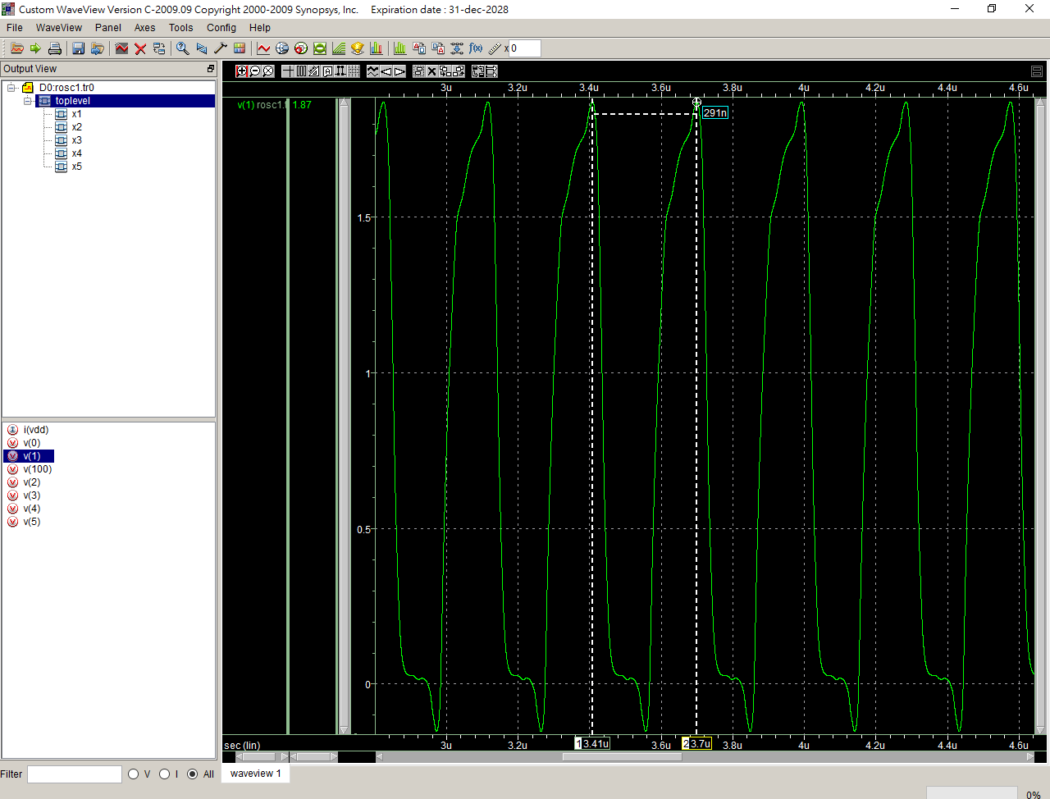

8u

ROSC

.lib 'C:\users\user\sp\cic018.l' tt

.SUBCKT INV 10 20 100 99

M1 20 10 100 100 P_18 W=10U L=2U

M2 20 10 99 99 N_18 W=5U L=2U

.ENDS INV

.SUBCKT NAND A B Y 100 99

M1 Y A 100 100 P_18 W=1U L=8U

M2 Y B 100 100 P_18 W=1U L=8U

M3 Y B 1 99 N_18 W=2U L=8U

M4 1 A 99 99 N_18 W=2U L=8U

.ENDS NAND

.SUBCKT NOR A B Y 100 99

M1 1 A 100 100 P_18 W=2U L=2U

M2 Y B 1 100 P_18 W=2U L=2U

M3 Y A 99 99 N_18 W=1U L=2U

M4 Y B 99 99 N_18 W=1U L=2U

.ENDS NOR

Vdd 100 0 dc PWL(0 0 1us 0 1.1us 1.8V 2us 1.8V)

*X1 1 2 100 0 INV

*X2 2 3 100 0 INV

*X3 3 4 100 0 INV

*X4 4 5 100 0 INV

*X5 5 1 100 0 INV

X1 1 1 2 100 0 NAND

X2 2 2 3 100 0 NAND

X3 3 3 4 100 0 NAND

X4 4 4 5 100 0 NAND

X5 5 5 1 100 0 NAND

*X1 1 1 2 100 0 NOR

*X2 2 2 3 100 0 NOR

*X3 3 3 4 100 0 NOR

*X4 4 4 5 100 0 NOR

*X5 5 5 1 100 0 NOR

**analysis

.op

.option post

.tran 1ps 10us 0 0.1ns

.probe

.end

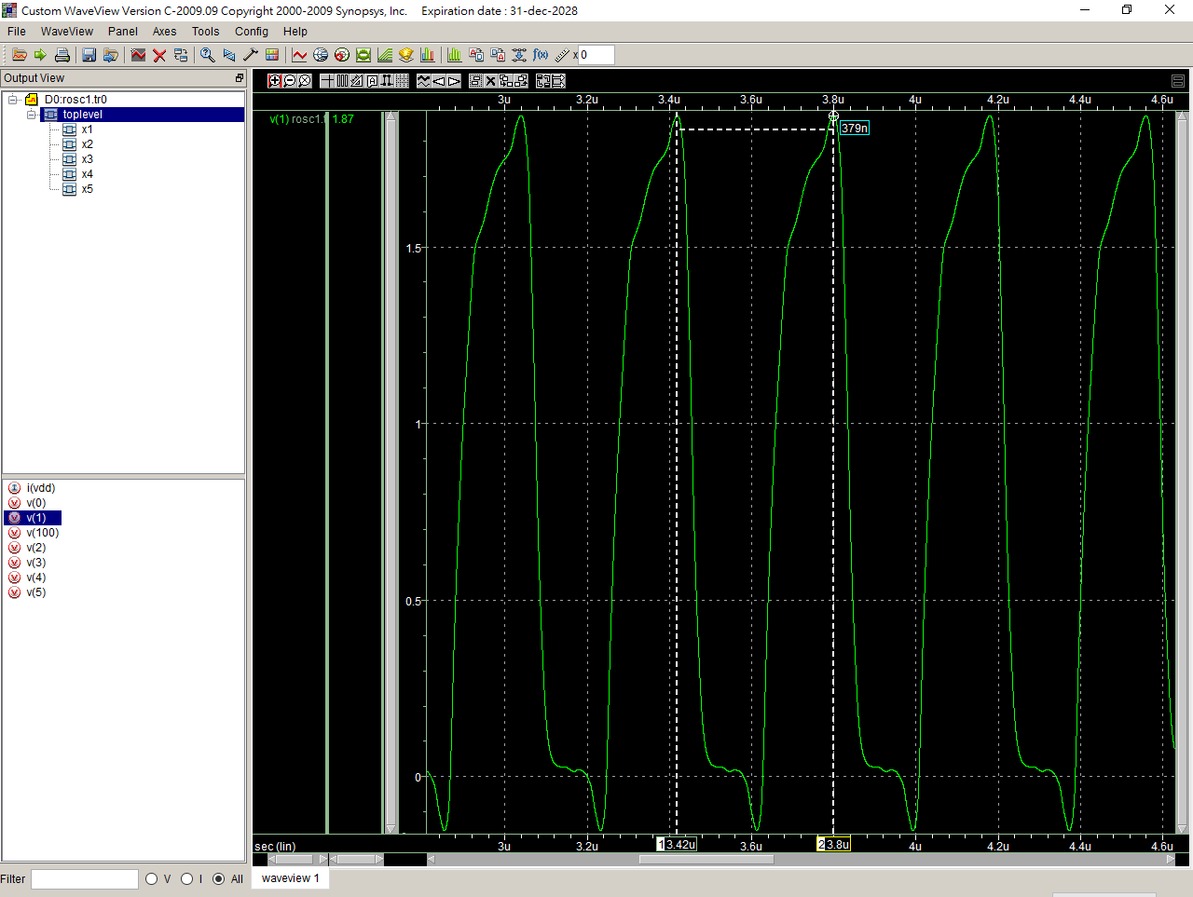

9u

ROSC

.lib 'C:\users\user\sp\cic018.l' tt

.SUBCKT INV 10 20 100 99

M1 20 10 100 100 P_18 W=10U L=2U

M2 20 10 99 99 N_18 W=5U L=2U

.ENDS INV

.SUBCKT NAND A B Y 100 99

M1 Y A 100 100 P_18 W=1U L=9U

M2 Y B 100 100 P_18 W=1U L=9U

M3 Y B 1 99 N_18 W=2U L=9U

M4 1 A 99 99 N_18 W=2U L=9U

.ENDS NAND

.SUBCKT NOR A B Y 100 99

M1 1 A 100 100 P_18 W=2U L=2U

M2 Y B 1 100 P_18 W=2U L=2U

M3 Y A 99 99 N_18 W=1U L=2U

M4 Y B 99 99 N_18 W=1U L=2U

.ENDS NOR

Vdd 100 0 dc PWL(0 0 1us 0 1.1us 1.8V 2us 1.8V)

*X1 1 2 100 0 INV

*X2 2 3 100 0 INV

*X3 3 4 100 0 INV

*X4 4 5 100 0 INV

*X5 5 1 100 0 INV

X1 1 1 2 100 0 NAND

X2 2 2 3 100 0 NAND

X3 3 3 4 100 0 NAND

X4 4 4 5 100 0 NAND

X5 5 5 1 100 0 NAND

*X1 1 1 2 100 0 NOR

*X2 2 2 3 100 0 NOR

*X3 3 3 4 100 0 NOR

*X4 4 4 5 100 0 NOR

*X5 5 5 1 100 0 NOR

**analysis

.op

.option post

.tran 1ps 10us 0 0.1ns

.probe

.end

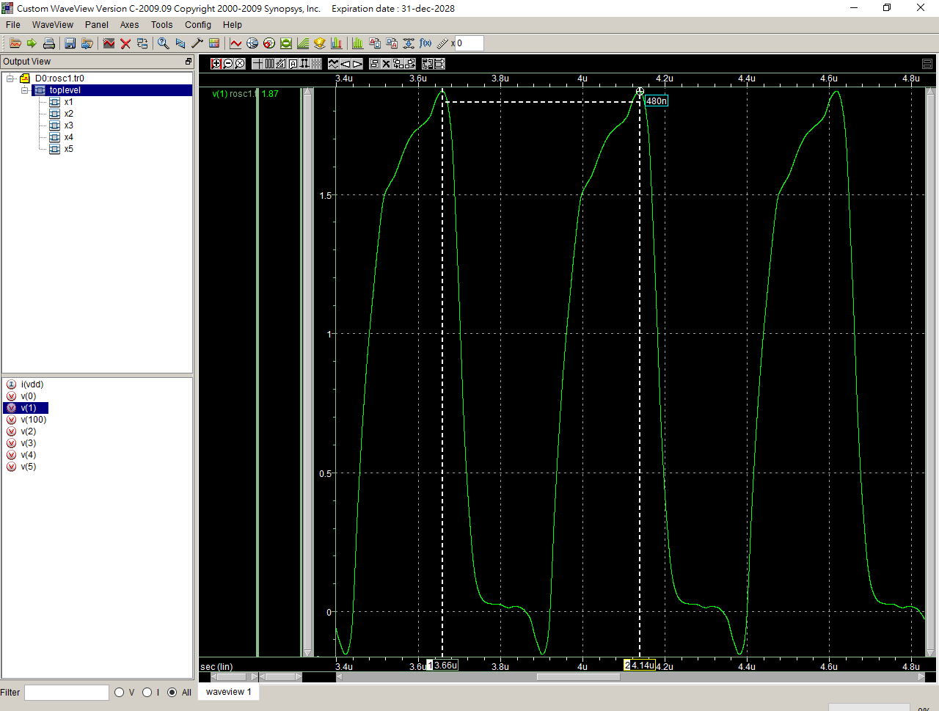

10u

ROSC

.lib 'C:\users\user\sp\cic018.l' tt

.SUBCKT INV 10 20 100 99

M1 20 10 100 100 P_18 W=10U L=2U

M2 20 10 99 99 N_18 W=5U L=2U

.ENDS INV

.SUBCKT NAND A B Y 100 99

M1 Y A 100 100 P_18 W=1U L=10U

M2 Y B 100 100 P_18 W=1U L=10U

M3 Y B 1 99 N_18 W=2U L=10U

M4 1 A 99 99 N_18 W=2U L=10U

.ENDS NAND

.SUBCKT NOR A B Y 100 99

M1 1 A 100 100 P_18 W=2U L=2U

M2 Y B 1 100 P_18 W=2U L=2U

M3 Y A 99 99 N_18 W=1U L=2U

M4 Y B 99 99 N_18 W=1U L=2U

.ENDS NOR

Vdd 100 0 dc PWL(0 0 1us 0 1.1us 1.8V 2us 1.8V)

*X1 1 2 100 0 INV

*X2 2 3 100 0 INV

*X3 3 4 100 0 INV

*X4 4 5 100 0 INV

*X5 5 1 100 0 INV

X1 1 1 2 100 0 NAND

X2 2 2 3 100 0 NAND

X3 3 3 4 100 0 NAND

X4 4 4 5 100 0 NAND

X5 5 5 1 100 0 NAND

*X1 1 1 2 100 0 NOR

*X2 2 2 3 100 0 NOR

*X3 3 3 4 100 0 NOR

*X4 4 4 5 100 0 NOR

*X5 5 5 1 100 0 NOR

**analysis

.op

.option post

.tran 1ps 10us 0 0.1ns

.probe

.end

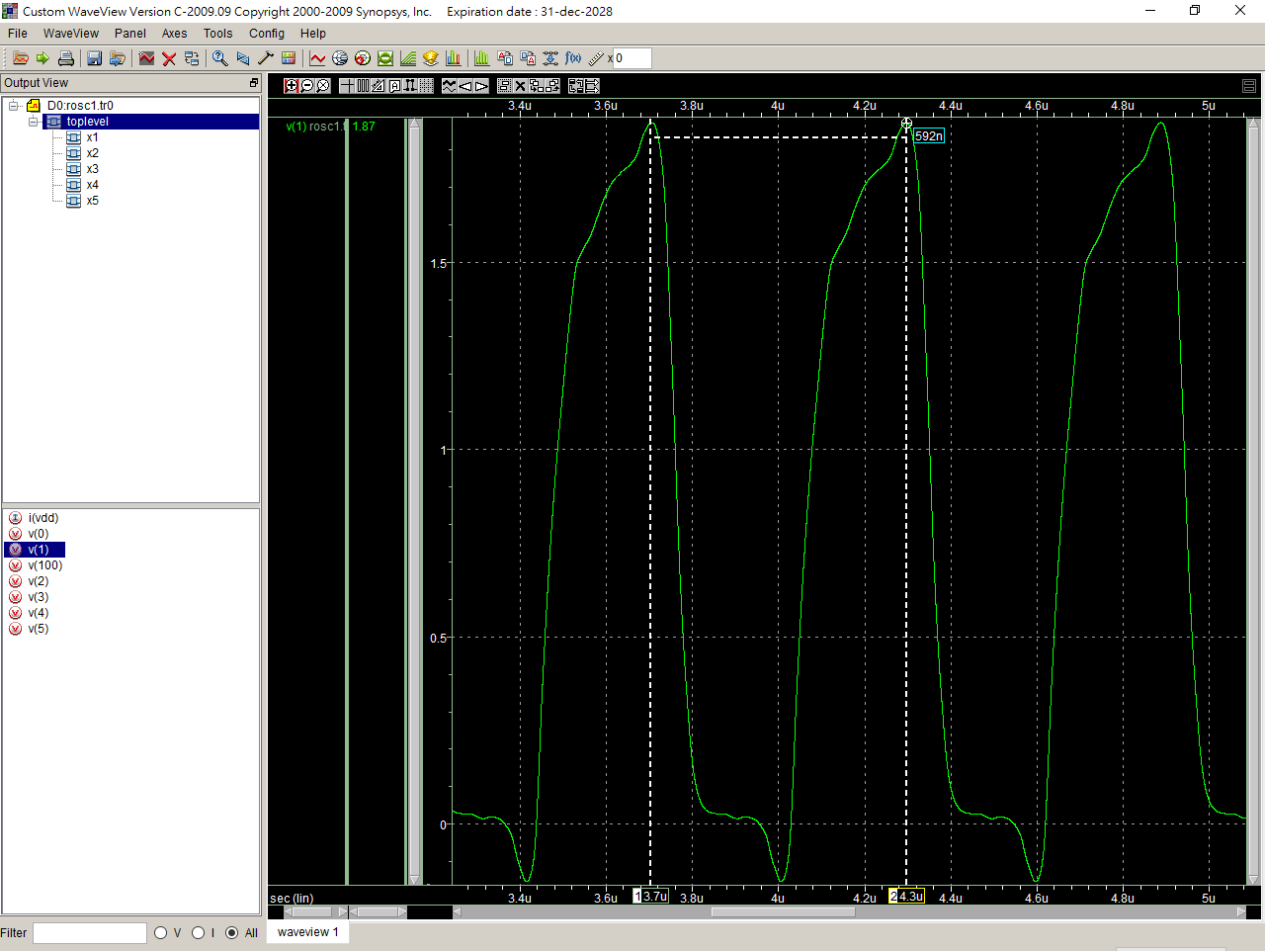

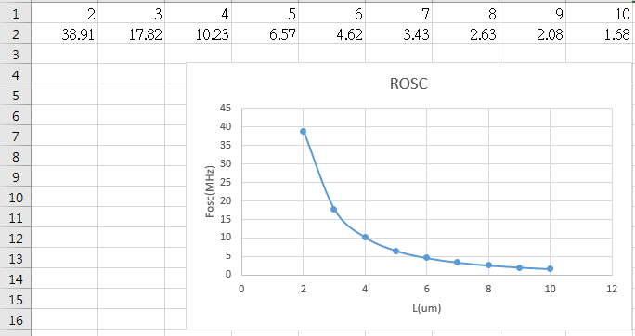

1u

ROSC

.lib 'C:\users\user\sp\cic018.l' tt

.SUBCKT INV 10 20 100 99

M1 20 10 100 100 P_18 W=10U L=2U

M2 20 10 99 99 N_18 W=5U L=2U

.ENDS INV

.SUBCKT NAND A B Y 100 99

M1 Y A 100 100 P_18 W=1U L=2U

M2 Y B 100 100 P_18 W=1U L=2U

M3 Y B 1 99 N_18 W=1U L=2U

M4 1 A 99 99 N_18 W=1U L=2U

.ENDS NAND

.SUBCKT NOR A B Y 100 99

M1 1 A 100 100 P_18 W=2U L=2U

M2 Y B 1 100 P_18 W=2U L=2U

M3 Y A 99 99 N_18 W=1U L=2U

M4 Y B 99 99 N_18 W=1U L=2U

.ENDS NOR

Vdd 100 0 dc PWL(0 0 1us 0 1.1us 1.8V 2us 1.8V)

*X1 1 2 100 0 INV

*X2 2 3 100 0 INV

*X3 3 4 100 0 INV

*X4 4 5 100 0 INV

*X5 5 1 100 0 INV

X1 1 1 2 100 0 NAND

X2 2 2 3 100 0 NAND

X3 3 3 4 100 0 NAND

X4 4 4 5 100 0 NAND

X5 5 5 1 100 0 NAND

*X1 1 1 2 100 0 NOR

*X2 2 2 3 100 0 NOR

*X3 3 3 4 100 0 NOR

*X4 4 4 5 100 0 NOR

*X5 5 5 1 100 0 NOR

**analysis

.op

.option post

.tran 1ps 10us 0 0.1ns

.probe

.end

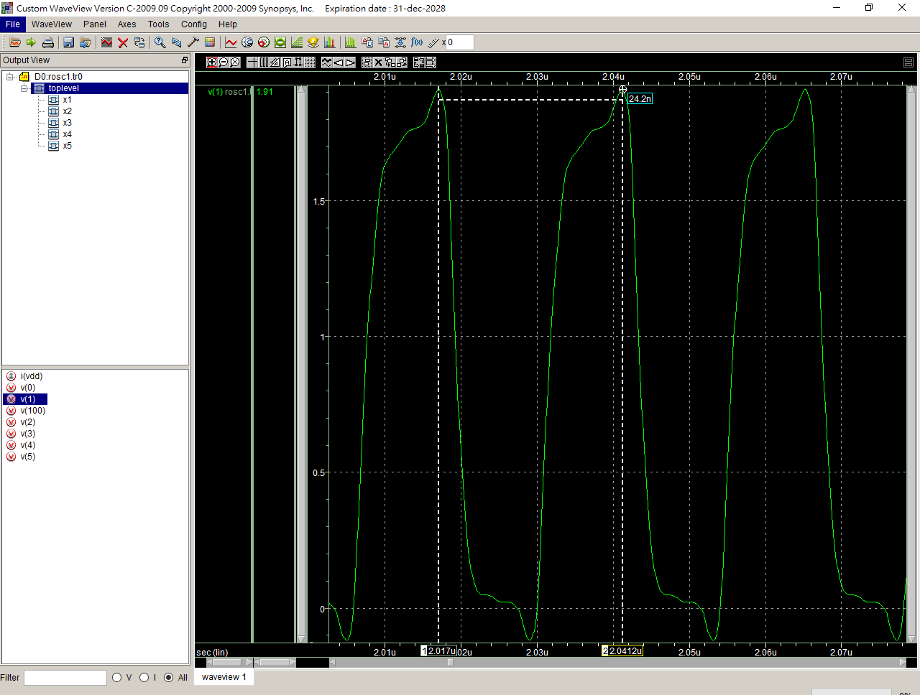

2u

ROSC

.lib 'C:\users\user\sp\cic018.l' tt

.SUBCKT INV 10 20 100 99

M1 20 10 100 100 P_18 W=10U L=2U

M2 20 10 99 99 N_18 W=5U L=2U

.ENDS INV

.SUBCKT NAND A B Y 100 99

M1 Y A 100 100 P_18 W=2U L=2U

M2 Y B 100 100 P_18 W=2U L=2U

M3 Y B 1 99 N_18 W=2U L=2U

M4 1 A 99 99 N_18 W=2U L=2U

.ENDS NAND

.SUBCKT NOR A B Y 100 99

M1 1 A 100 100 P_18 W=2U L=2U

M2 Y B 1 100 P_18 W=2U L=2U

M3 Y A 99 99 N_18 W=1U L=2U

M4 Y B 99 99 N_18 W=1U L=2U

.ENDS NOR

Vdd 100 0 dc PWL(0 0 1us 0 1.1us 1.8V 2us 1.8V)

*X1 1 2 100 0 INV

*X2 2 3 100 0 INV

*X3 3 4 100 0 INV

*X4 4 5 100 0 INV

*X5 5 1 100 0 INV

X1 1 1 2 100 0 NAND

X2 2 2 3 100 0 NAND

X3 3 3 4 100 0 NAND

X4 4 4 5 100 0 NAND

X5 5 5 1 100 0 NAND

*X1 1 1 2 100 0 NOR

*X2 2 2 3 100 0 NOR

*X3 3 3 4 100 0 NOR

*X4 4 4 5 100 0 NOR

*X5 5 5 1 100 0 NOR

**analysis

.op

.option post

.tran 1ps 10us 0 0.1ns

.probe

.end

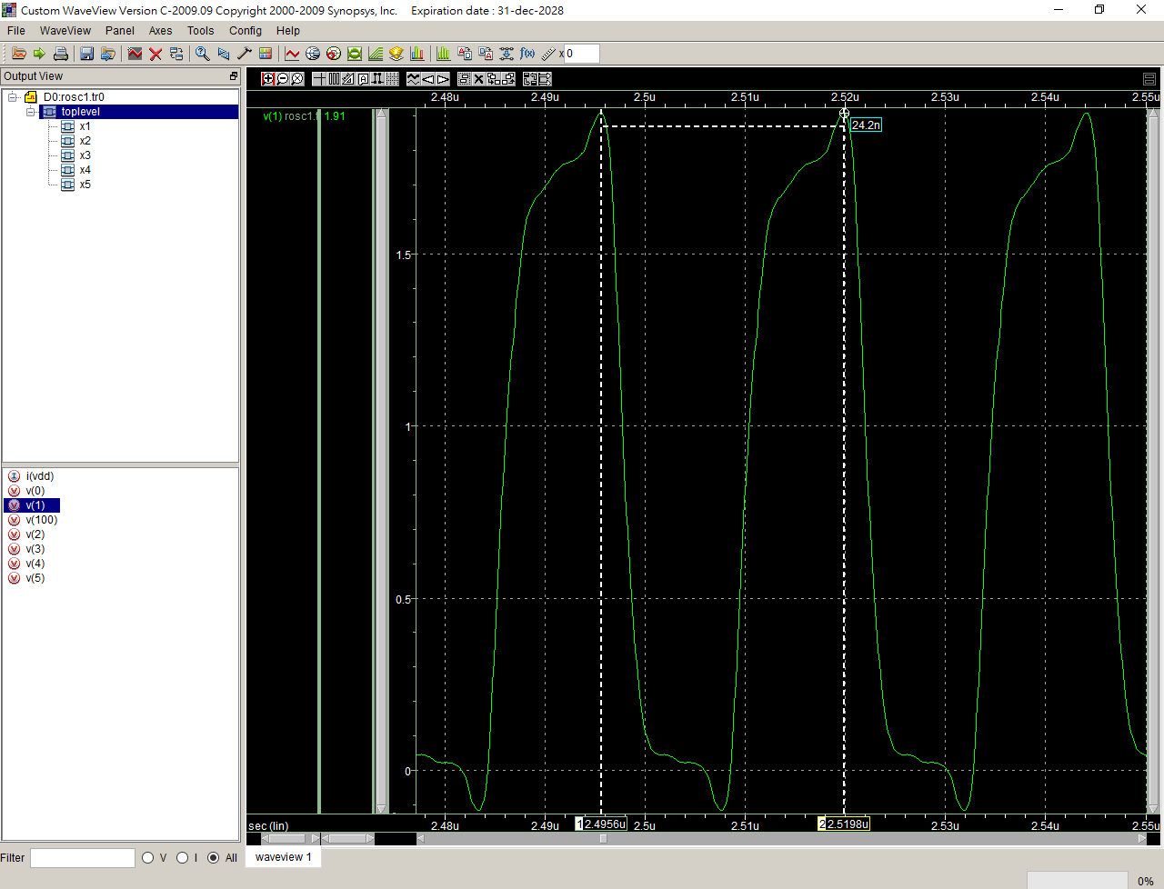

ROSC

.lib 'C:\users\user\sp\cic018.l' tt

.SUBCKT INV 10 20 100 99

M1 20 10 100 100 P_18 W=10U L=2U

M2 20 10 99 99 N_18 W=5U L=2U

.ENDS INV

.SUBCKT NAND A B Y 100 99

M1 Y A 100 100 P_18 W=3U L=2U

M2 Y B 100 100 P_18 W=3U L=2U

M3 Y B 1 99 N_18 W=3U L=2U

M4 1 A 99 99 N_18 W=3U L=2U

.ENDS NAND

.SUBCKT NOR A B Y 100 99

M1 1 A 100 100 P_18 W=2U L=2U

M2 Y B 1 100 P_18 W=2U L=2U

M3 Y A 99 99 N_18 W=1U L=2U

M4 Y B 99 99 N_18 W=1U L=2U

.ENDS NOR

Vdd 100 0 dc PWL(0 0 1us 0 1.1us 1.8V 2us 1.8V)

*X1 1 2 100 0 INV

*X2 2 3 100 0 INV

*X3 3 4 100 0 INV

*X4 4 5 100 0 INV

*X5 5 1 100 0 INV

X1 1 1 2 100 0 NAND

X2 2 2 3 100 0 NAND

X3 3 3 4 100 0 NAND

X4 4 4 5 100 0 NAND

X5 5 5 1 100 0 NAND

*X1 1 1 2 100 0 NOR

*X2 2 2 3 100 0 NOR

*X3 3 3 4 100 0 NOR

*X4 4 4 5 100 0 NOR

*X5 5 5 1 100 0 NOR

**analysis

.op

.option post

.tran 1ps 10us 0 0.1ns

.probe

.end

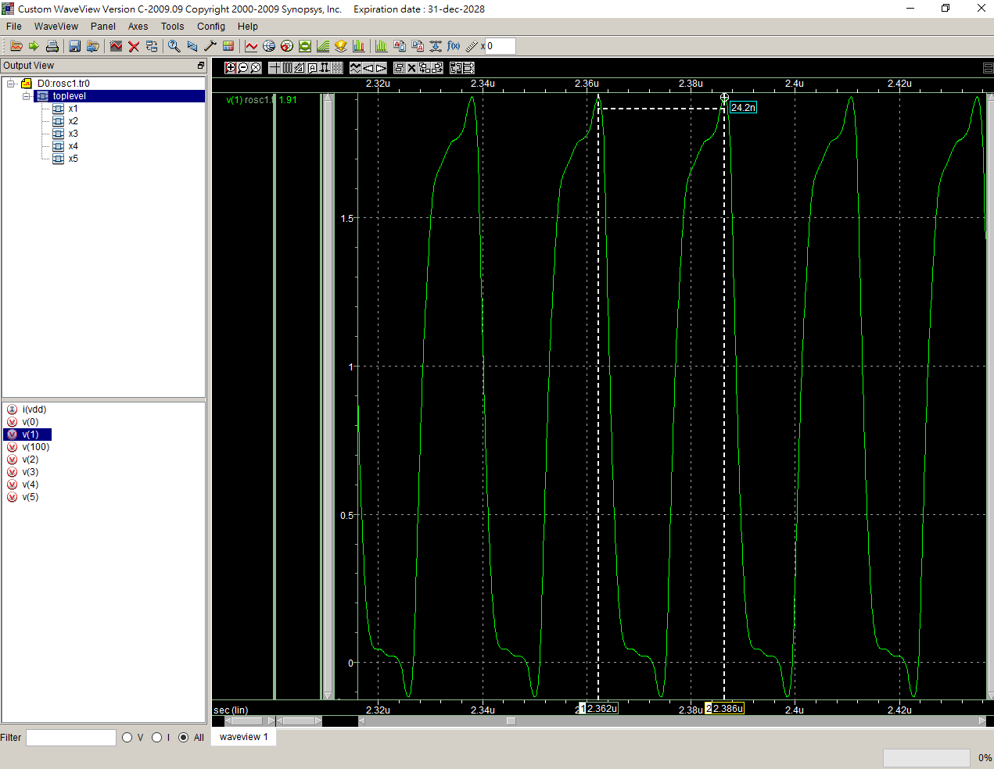

ROSC

.lib 'C:\users\user\sp\cic018.l' tt

.SUBCKT INV 10 20 100 99

M1 20 10 100 100 P_18 W=10U L=2U

M2 20 10 99 99 N_18 W=5U L=2U

.ENDS INV

.SUBCKT NAND A B Y 100 99

M1 Y A 100 100 P_18 W=4U L=2U

M2 Y B 100 100 P_18 W=4U L=2U

M3 Y B 1 99 N_18 W=4U L=2U

M4 1 A 99 99 N_18 W=4U L=2U

.ENDS NAND

.SUBCKT NOR A B Y 100 99

M1 1 A 100 100 P_18 W=2U L=2U

M2 Y B 1 100 P_18 W=2U L=2U

M3 Y A 99 99 N_18 W=1U L=2U

M4 Y B 99 99 N_18 W=1U L=2U

.ENDS NOR

Vdd 100 0 dc PWL(0 0 1us 0 1.1us 1.8V 2us 1.8V)

*X1 1 2 100 0 INV

*X2 2 3 100 0 INV

*X3 3 4 100 0 INV

*X4 4 5 100 0 INV

*X5 5 1 100 0 INV

X1 1 1 2 100 0 NAND

X2 2 2 3 100 0 NAND

X3 3 3 4 100 0 NAND

X4 4 4 5 100 0 NAND

X5 5 5 1 100 0 NAND

*X1 1 1 2 100 0 NOR

*X2 2 2 3 100 0 NOR

*X3 3 3 4 100 0 NOR

*X4 4 4 5 100 0 NOR

*X5 5 5 1 100 0 NOR

**analysis

.op

.option post

.tran 1ps 10us 0 0.1ns

.probe

.end

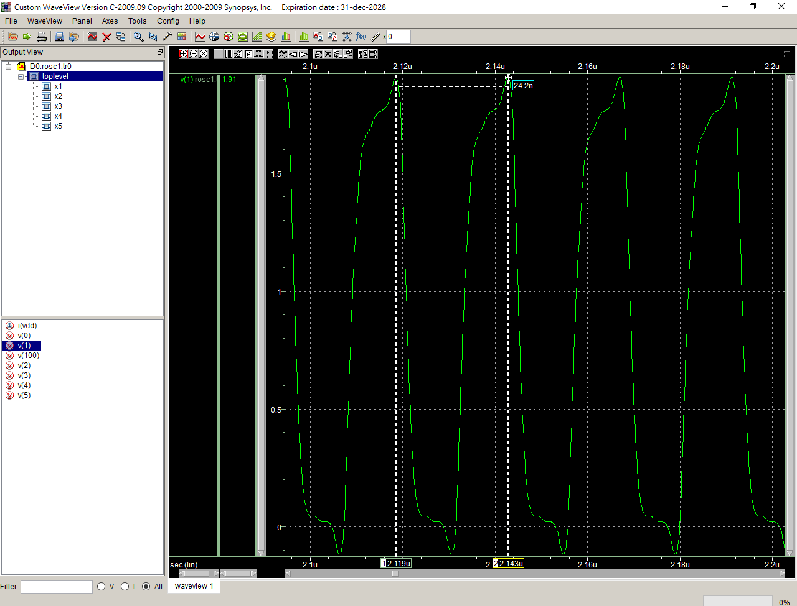

ROSC

.lib 'C:\users\user\sp\cic018.l' tt

.SUBCKT INV 10 20 100 99

M1 20 10 100 100 P_18 W=10U L=2U

M2 20 10 99 99 N_18 W=5U L=2U

.ENDS INV

.SUBCKT NAND A B Y 100 99

M1 Y A 100 100 P_18 W=5U L=2U

M2 Y B 100 100 P_18 W=5U L=2U

M3 Y B 1 99 N_18 W=5U L=2U

M4 1 A 99 99 N_18 W=5U L=2U

.ENDS NAND

.SUBCKT NOR A B Y 100 99

M1 1 A 100 100 P_18 W=2U L=2U

M2 Y B 1 100 P_18 W=2U L=2U

M3 Y A 99 99 N_18 W=1U L=2U

M4 Y B 99 99 N_18 W=1U L=2U

.ENDS NOR

Vdd 100 0 dc PWL(0 0 1us 0 1.1us 1.8V 2us 1.8V)

*X1 1 2 100 0 INV

*X2 2 3 100 0 INV

*X3 3 4 100 0 INV

*X4 4 5 100 0 INV

*X5 5 1 100 0 INV

X1 1 1 2 100 0 NAND

X2 2 2 3 100 0 NAND

X3 3 3 4 100 0 NAND

X4 4 4 5 100 0 NAND

X5 5 5 1 100 0 NAND

*X1 1 1 2 100 0 NOR

*X2 2 2 3 100 0 NOR

*X3 3 3 4 100 0 NOR

*X4 4 4 5 100 0 NOR

*X5 5 5 1 100 0 NOR

**analysis

.op

.option post

.tran 1ps 10us 0 0.1ns

.probe

.end

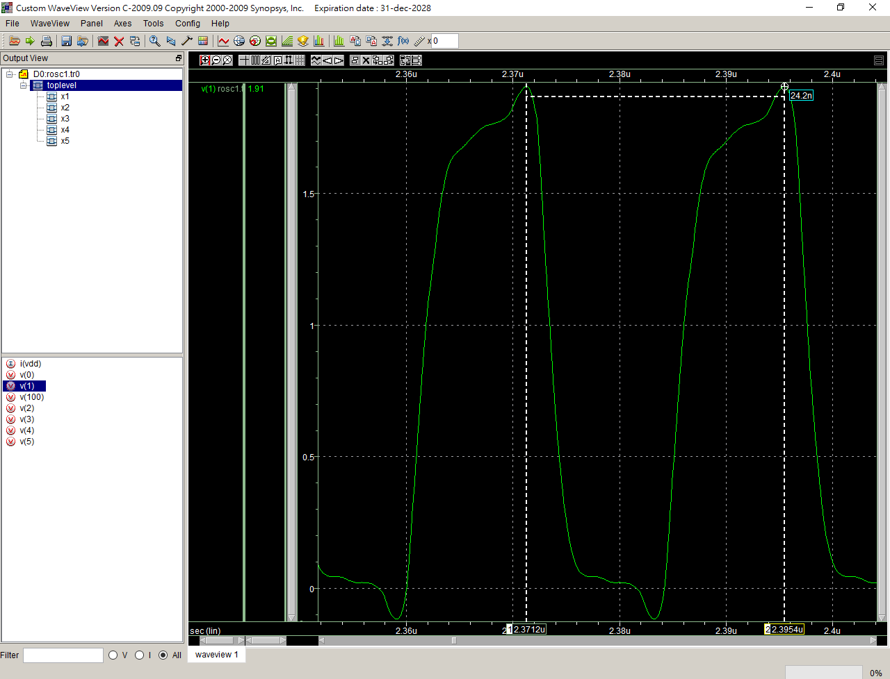

ROSC

.lib 'C:\users\user\sp\cic018.l' tt

.SUBCKT INV 10 20 100 99

M1 20 10 100 100 P_18 W=10U L=2U

M2 20 10 99 99 N_18 W=5U L=2U

.ENDS INV

.SUBCKT NAND A B Y 100 99

M1 Y A 100 100 P_18 W=6U L=2U

M2 Y B 100 100 P_18 W=6U L=2U

M3 Y B 1 99 N_18 W=6U L=2U

M4 1 A 99 99 N_18 W=6U L=2U

.ENDS NAND

.SUBCKT NOR A B Y 100 99

M1 1 A 100 100 P_18 W=2U L=2U

M2 Y B 1 100 P_18 W=2U L=2U

M3 Y A 99 99 N_18 W=1U L=2U

M4 Y B 99 99 N_18 W=1U L=2U

.ENDS NOR

Vdd 100 0 dc PWL(0 0 1us 0 1.1us 1.8V 2us 1.8V)

*X1 1 2 100 0 INV

*X2 2 3 100 0 INV

*X3 3 4 100 0 INV

*X4 4 5 100 0 INV

*X5 5 1 100 0 INV

X1 1 1 2 100 0 NAND

X2 2 2 3 100 0 NAND

X3 3 3 4 100 0 NAND

X4 4 4 5 100 0 NAND

X5 5 5 1 100 0 NAND

*X1 1 1 2 100 0 NOR

*X2 2 2 3 100 0 NOR

*X3 3 3 4 100 0 NOR

*X4 4 4 5 100 0 NOR

*X5 5 5 1 100 0 NOR

**analysis

.op

.option post

.tran 1ps 10us 0 0.1ns

.probe

.end

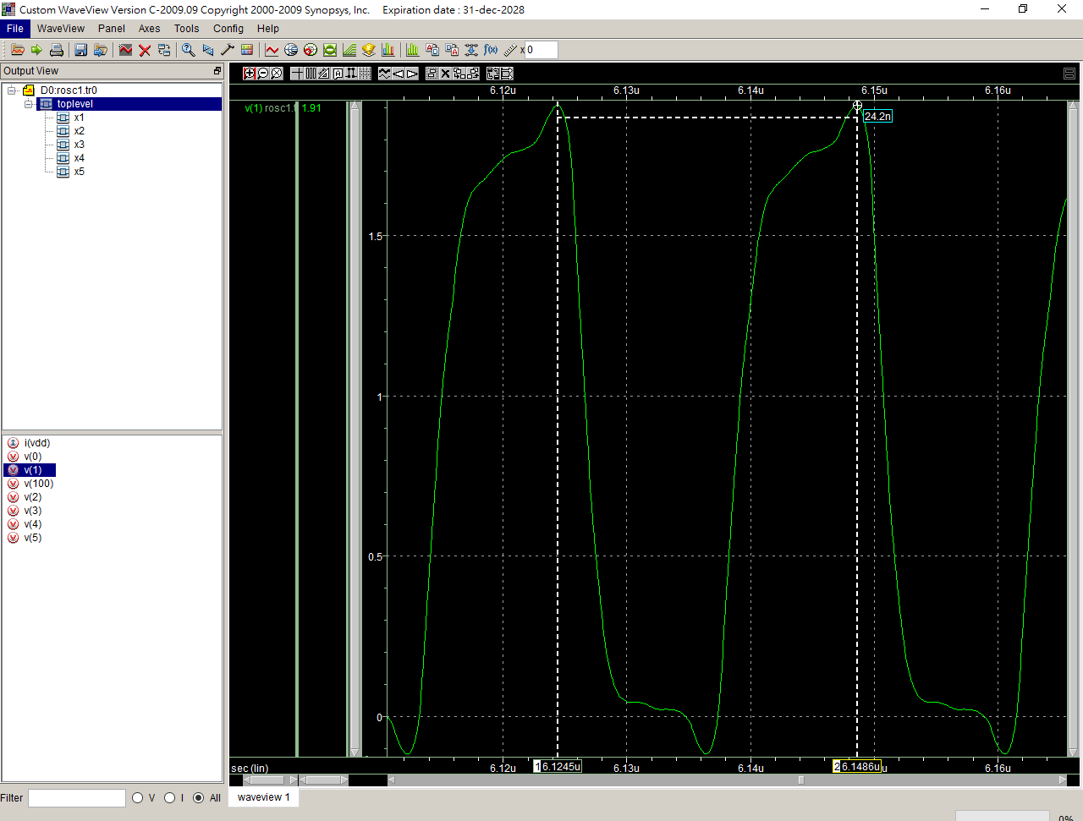

ROSC

.lib 'C:\users\user\sp\cic018.l' tt

.SUBCKT INV 10 20 100 99

M1 20 10 100 100 P_18 W=10U L=2U

M2 20 10 99 99 N_18 W=5U L=2U

.ENDS INV

.SUBCKT NAND A B Y 100 99

M1 Y A 100 100 P_18 W=7U L=2U

M2 Y B 100 100 P_18 W=7U L=2U

M3 Y B 1 99 N_18 W=7U L=2U

M4 1 A 99 99 N_18 W=7U L=2U

.ENDS NAND

.SUBCKT NOR A B Y 100 99

M1 1 A 100 100 P_18 W=2U L=2U

M2 Y B 1 100 P_18 W=2U L=2U

M3 Y A 99 99 N_18 W=1U L=2U

M4 Y B 99 99 N_18 W=1U L=2U

.ENDS NOR

Vdd 100 0 dc PWL(0 0 1us 0 1.1us 1.8V 2us 1.8V)

*X1 1 2 100 0 INV

*X2 2 3 100 0 INV

*X3 3 4 100 0 INV

*X4 4 5 100 0 INV

*X5 5 1 100 0 INV

X1 1 1 2 100 0 NAND

X2 2 2 3 100 0 NAND

X3 3 3 4 100 0 NAND

X4 4 4 5 100 0 NAND

X5 5 5 1 100 0 NAND

*X1 1 1 2 100 0 NOR

*X2 2 2 3 100 0 NOR

*X3 3 3 4 100 0 NOR

*X4 4 4 5 100 0 NOR

*X5 5 5 1 100 0 NOR

**analysis

.op

.option post

.tran 1ps 10us 0 0.1ns

.probe

.end

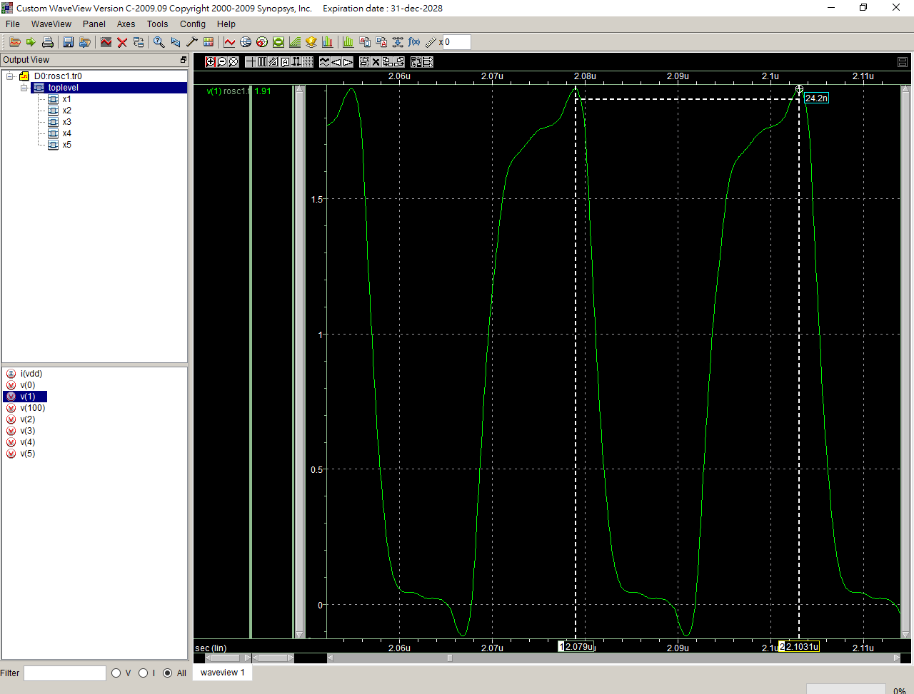

ROSC

.lib 'C:\users\user\sp\cic018.l' tt

.SUBCKT INV 10 20 100 99

M1 20 10 100 100 P_18 W=10U L=2U

M2 20 10 99 99 N_18 W=5U L=2U

.ENDS INV

.SUBCKT NAND A B Y 100 99

M1 Y A 100 100 P_18 W=8U L=2U

M2 Y B 100 100 P_18 W=8U L=2U

M3 Y B 1 99 N_18 W=8U L=2U

M4 1 A 99 99 N_18 W=8U L=2U

.ENDS NAND

.SUBCKT NOR A B Y 100 99

M1 1 A 100 100 P_18 W=2U L=2U

M2 Y B 1 100 P_18 W=2U L=2U

M3 Y A 99 99 N_18 W=1U L=2U

M4 Y B 99 99 N_18 W=1U L=2U

.ENDS NOR

Vdd 100 0 dc PWL(0 0 1us 0 1.1us 1.8V 2us 1.8V)

*X1 1 2 100 0 INV

*X2 2 3 100 0 INV

*X3 3 4 100 0 INV

*X4 4 5 100 0 INV

*X5 5 1 100 0 INV

X1 1 1 2 100 0 NAND

X2 2 2 3 100 0 NAND

X3 3 3 4 100 0 NAND

X4 4 4 5 100 0 NAND

X5 5 5 1 100 0 NAND

*X1 1 1 2 100 0 NOR

*X2 2 2 3 100 0 NOR

*X3 3 3 4 100 0 NOR

*X4 4 4 5 100 0 NOR

*X5 5 5 1 100 0 NOR

**analysis

.op

.option post

.tran 1ps 10us 0 0.1ns

.probe

.end

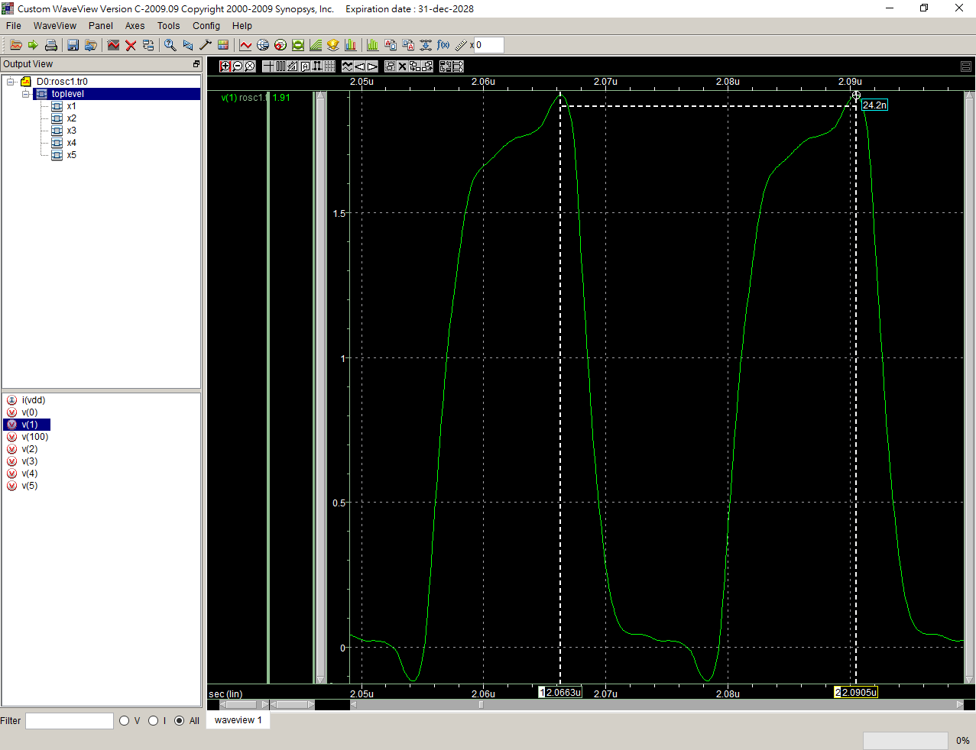

ROSC

.lib 'C:\users\user\sp\cic018.l' tt

.SUBCKT INV 10 20 100 99

M1 20 10 100 100 P_18 W=10U L=2U

M2 20 10 99 99 N_18 W=5U L=2U

.ENDS INV

.SUBCKT NAND A B Y 100 99

M1 Y A 100 100 P_18 W=9U L=2U

M2 Y B 100 100 P_18 W=9U L=2U

M3 Y B 1 99 N_18 W=9U L=2U

M4 1 A 99 99 N_18 W=9U L=2U

.ENDS NAND

.SUBCKT NOR A B Y 100 99

M1 1 A 100 100 P_18 W=2U L=2U

M2 Y B 1 100 P_18 W=2U L=2U

M3 Y A 99 99 N_18 W=1U L=2U

M4 Y B 99 99 N_18 W=1U L=2U

.ENDS NOR

Vdd 100 0 dc PWL(0 0 1us 0 1.1us 1.8V 2us 1.8V)

*X1 1 2 100 0 INV

*X2 2 3 100 0 INV

*X3 3 4 100 0 INV

*X4 4 5 100 0 INV

*X5 5 1 100 0 INV

X1 1 1 2 100 0 NAND

X2 2 2 3 100 0 NAND

X3 3 3 4 100 0 NAND

X4 4 4 5 100 0 NAND

X5 5 5 1 100 0 NAND

*X1 1 1 2 100 0 NOR

*X2 2 2 3 100 0 NOR

*X3 3 3 4 100 0 NOR

*X4 4 4 5 100 0 NOR

*X5 5 5 1 100 0 NOR

**analysis

.op

.option post

.tran 1ps 10us 0 0.1ns

.probe

.end

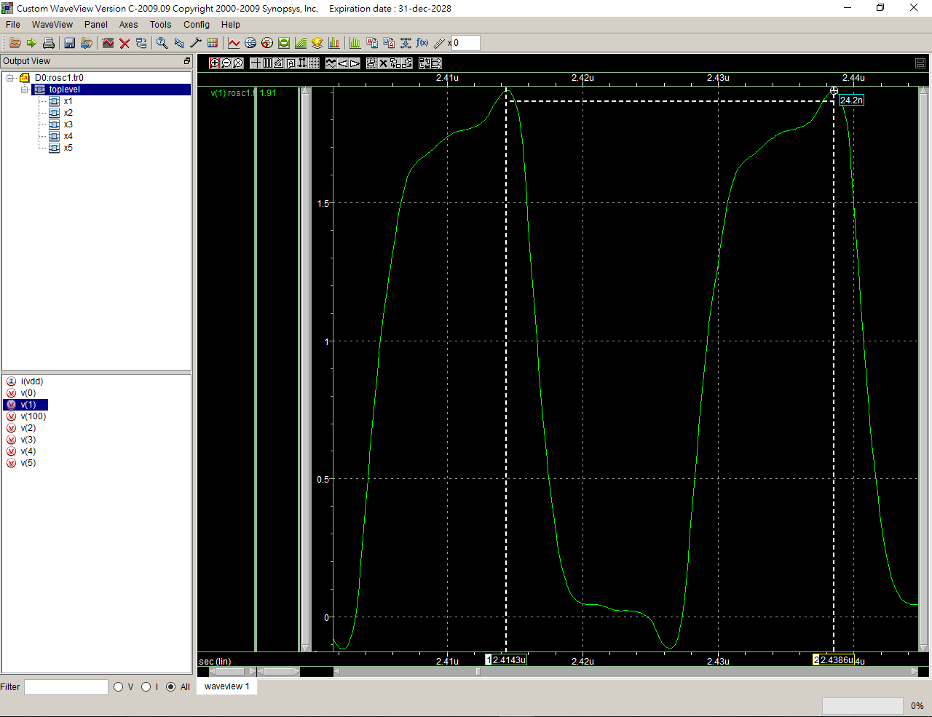

ROSC

.lib 'C:\users\user\sp\cic018.l' tt

.SUBCKT INV 10 20 100 99

M1 20 10 100 100 P_18 W=10U L=2U

M2 20 10 99 99 N_18 W=5U L=2U

.ENDS INV

.SUBCKT NAND A B Y 100 99

M1 Y A 100 100 P_18 W=10U L=2U

M2 Y B 100 100 P_18 W=10U L=2U

M3 Y B 1 99 N_18 W=10U L=2U

M4 1 A 99 99 N_18 W=10U L=2U

.ENDS NAND

.SUBCKT NOR A B Y 100 99

M1 1 A 100 100 P_18 W=2U L=2U

M2 Y B 1 100 P_18 W=2U L=2U

M3 Y A 99 99 N_18 W=1U L=2U

M4 Y B 99 99 N_18 W=1U L=2U

.ENDS NOR

Vdd 100 0 dc PWL(0 0 1us 0 1.1us 1.8V 2us 1.8V)

*X1 1 2 100 0 INV

*X2 2 3 100 0 INV

*X3 3 4 100 0 INV

*X4 4 5 100 0 INV

*X5 5 1 100 0 INV

X1 1 1 2 100 0 NAND

X2 2 2 3 100 0 NAND

X3 3 3 4 100 0 NAND

X4 4 4 5 100 0 NAND

X5 5 5 1 100 0 NAND

*X1 1 1 2 100 0 NOR

*X2 2 2 3 100 0 NOR

*X3 3 3 4 100 0 NOR

*X4 4 4 5 100 0 NOR

*X5 5 5 1 100 0 NOR

**analysis

.op

.option post

.tran 1ps 10us 0 0.1ns

.probe

.end

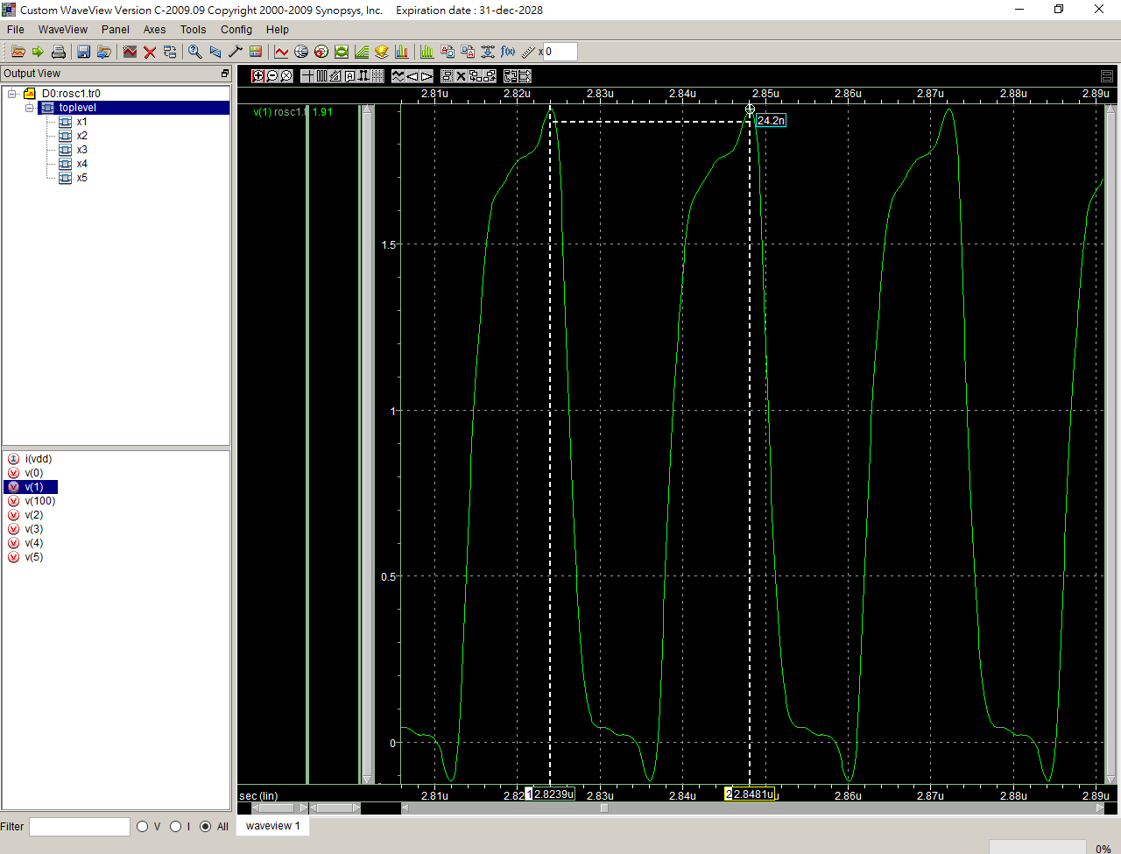

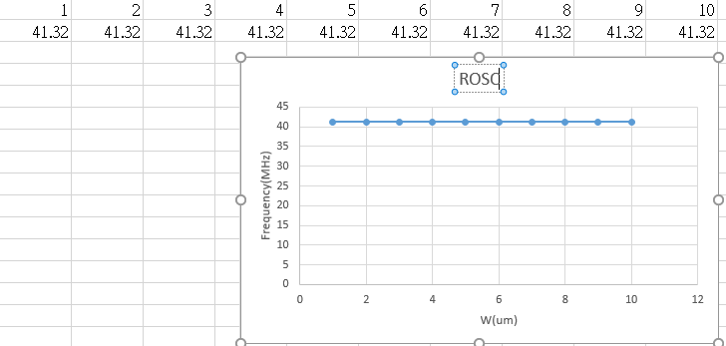

Lab7

2u

ROSCT2

.lib "C:\synopsys\cic018.l" tt

.SUBCKT INV 10 20 100 99

M1 20 10 100 100 P_18 W=2U L=2U

M2 20 10 99 99 N_18 W=2U L=2U

.ENDS INV

.SUBCKT NAND A B Y 100 99

M1 Y A 100 100 P_18 W=1u L=2u

M2 Y B 100 100 P_18 W=1u L=2u

M3 Y B 1 99 N_18 W=2u L=2u

M4 1 A 99 99 N_18 W=2u L=2u

.ENDS NAND

.SUBCKT NOR A B Y 100 99

M1 1 A 100 100 P_18 W=2u L=2u

M2 Y B 1 100 P_18 W=2u L=2u

M3 Y A 99 99 N_18 W=1u L=2u

M4 Y B 99 99 N_18 W=1u L=2u

.ENDS NOR

Vdd 100 0 dc PWL(0 0 1us 0 1.1us 1.8v 2us 1.8v)

*X1 1 2 100 0 INV

*X2 2 3 100 0 INV

*X3 3 4 100 0 INV

*X4 4 5 100 0 INV

*X5 5 1 100 0 INV

*X1 1 1 2 100 0 NAND

*X2 2 2 3 100 0 NAND

*X3 3 3 4 100 0 NAND

*X4 4 4 5 100 0 NAND

*X5 5 5 1 100 0 NAND

X1 1 1 2 100 0 NOR

X2 2 2 3 100 0 NOR

X3 3 3 4 100 0 NOR

X4 4 4 5 100 0 NOR

X5 5 5 1 100 0 NOR

**analysis

.op

.option post

.tran 1ps 10us 0 0.1ns

.probe

.end

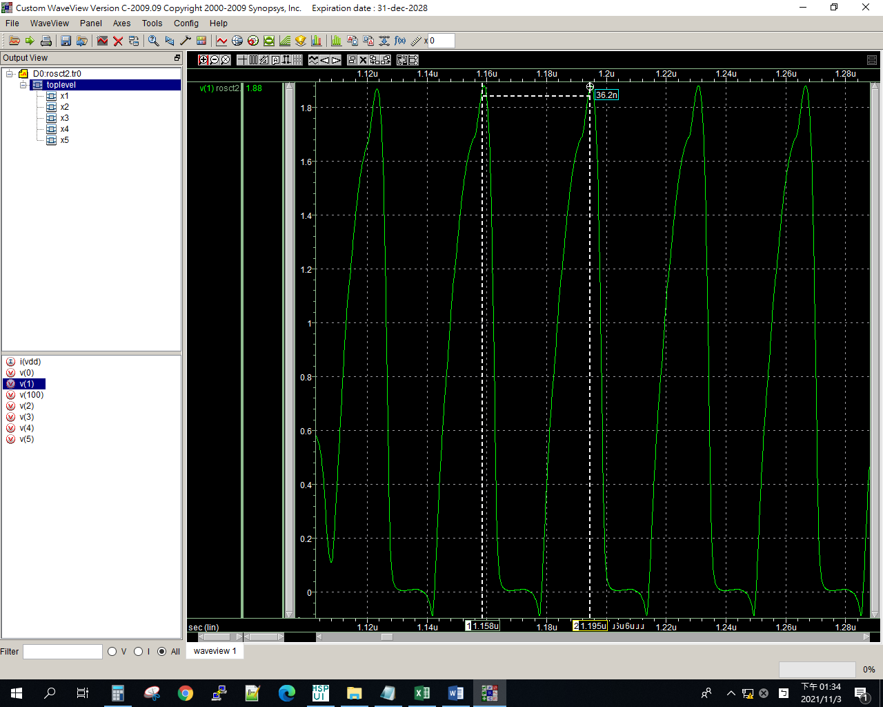

3u

ROSCT2

.lib "C:\synopsys\cic018.l" tt

.SUBCKT INV 10 20 100 99

M1 20 10 100 100 P_18 W=2U L=2U

M2 20 10 99 99 N_18 W=2U L=2U

.ENDS INV

.SUBCKT NAND A B Y 100 99

M1 Y A 100 100 P_18 W=1u L=2u

M2 Y B 100 100 P_18 W=1u L=2u

M3 Y B 1 99 N_18 W=2u L=2u

M4 1 A 99 99 N_18 W=2u L=2u

.ENDS NAND

.SUBCKT NOR A B Y 100 99

M1 1 A 100 100 P_18 W=2u L=3u

M2 Y B 1 100 P_18 W=2u L=3u

M3 Y A 99 99 N_18 W=1u L=3u

M4 Y B 99 99 N_18 W=1u L=3u

.ENDS NOR

Vdd 100 0 dc PWL(0 0 1us 0 1.1us 1.8v 2us 1.8v)

*X1 1 2 100 0 INV

*X2 2 3 100 0 INV

*X3 3 4 100 0 INV

*X4 4 5 100 0 INV

*X5 5 1 100 0 INV

*X1 1 1 2 100 0 NAND

*X2 2 2 3 100 0 NAND

*X3 3 3 4 100 0 NAND

*X4 4 4 5 100 0 NAND

*X5 5 5 1 100 0 NAND

X1 1 1 2 100 0 NOR

X2 2 2 3 100 0 NOR

X3 3 3 4 100 0 NOR

X4 4 4 5 100 0 NOR

X5 5 5 1 100 0 NOR

**analysis

.op

.option post

.tran 1ps 10us 0 0.1ns

.probe

.end

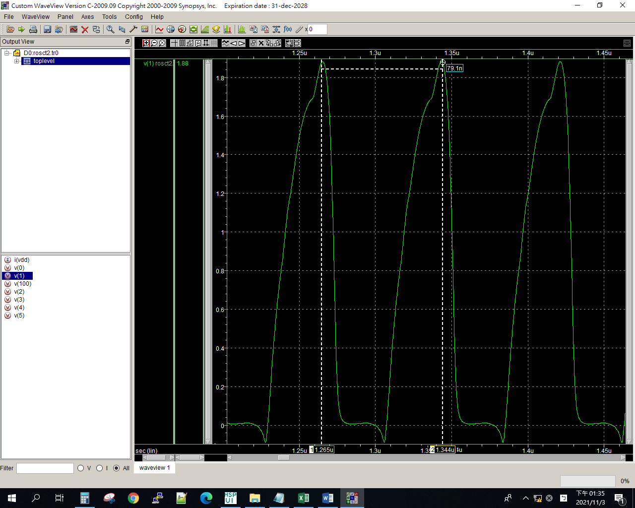

4u

ROSCT2

.lib "C:\synopsys\cic018.l" tt

.SUBCKT INV 10 20 100 99

M1 20 10 100 100 P_18 W=2U L=2U

M2 20 10 99 99 N_18 W=2U L=2U

.ENDS INV

.SUBCKT NAND A B Y 100 99

M1 Y A 100 100 P_18 W=1u L=2u

M2 Y B 100 100 P_18 W=1u L=2u

M3 Y B 1 99 N_18 W=2u L=2u

M4 1 A 99 99 N_18 W=2u L=2u

.ENDS NAND

.SUBCKT NOR A B Y 100 99

M1 1 A 100 100 P_18 W=2u L=4u

M2 Y B 1 100 P_18 W=2u L=4u

M3 Y A 99 99 N_18 W=1u L=4u

M4 Y B 99 99 N_18 W=1u L=4u

.ENDS NOR

Vdd 100 0 dc PWL(0 0 1us 0 1.1us 1.8v 2us 1.8v)

*X1 1 2 100 0 INV

*X2 2 3 100 0 INV

*X3 3 4 100 0 INV

*X4 4 5 100 0 INV

*X5 5 1 100 0 INV

*X1 1 1 2 100 0 NAND

*X2 2 2 3 100 0 NAND

*X3 3 3 4 100 0 NAND

*X4 4 4 5 100 0 NAND

*X5 5 5 1 100 0 NAND

X1 1 1 2 100 0 NOR

X2 2 2 3 100 0 NOR

X3 3 3 4 100 0 NOR

X4 4 4 5 100 0 NOR

X5 5 5 1 100 0 NOR

**analysis

.op

.option post

.tran 1ps 10us 0 0.1ns

.probe

.end

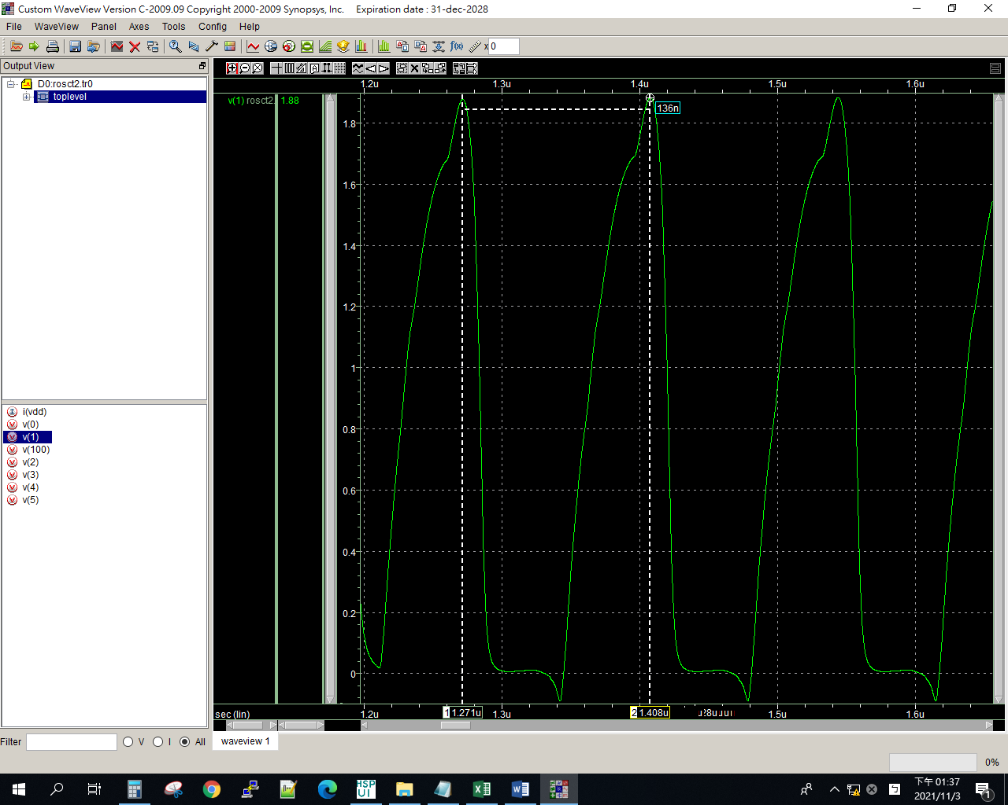

5u

ROSCT2

.lib "C:\synopsys\cic018.l" tt

.SUBCKT INV 10 20 100 99

M1 20 10 100 100 P_18 W=2U L=2U

M2 20 10 99 99 N_18 W=2U L=2U

.ENDS INV

.SUBCKT NAND A B Y 100 99

M1 Y A 100 100 P_18 W=1u L=2u

M2 Y B 100 100 P_18 W=1u L=2u

M3 Y B 1 99 N_18 W=2u L=2u

M4 1 A 99 99 N_18 W=2u L=2u

.ENDS NAND

.SUBCKT NOR A B Y 100 99

M1 1 A 100 100 P_18 W=2u L=5u

M2 Y B 1 100 P_18 W=2u L=5u

M3 Y A 99 99 N_18 W=1u L=5u

M4 Y B 99 99 N_18 W=1u L=5u

.ENDS NOR

Vdd 100 0 dc PWL(0 0 1us 0 1.1us 1.8v 2us 1.8v)

*X1 1 2 100 0 INV

*X2 2 3 100 0 INV

*X3 3 4 100 0 INV

*X4 4 5 100 0 INV

*X5 5 1 100 0 INV

*X1 1 1 2 100 0 NAND

*X2 2 2 3 100 0 NAND

*X3 3 3 4 100 0 NAND

*X4 4 4 5 100 0 NAND

*X5 5 5 1 100 0 NAND

X1 1 1 2 100 0 NOR

X2 2 2 3 100 0 NOR

X3 3 3 4 100 0 NOR

X4 4 4 5 100 0 NOR

X5 5 5 1 100 0 NOR

**analysis

.op

.option post

.tran 1ps 10us 0 0.1ns

.probe

.end

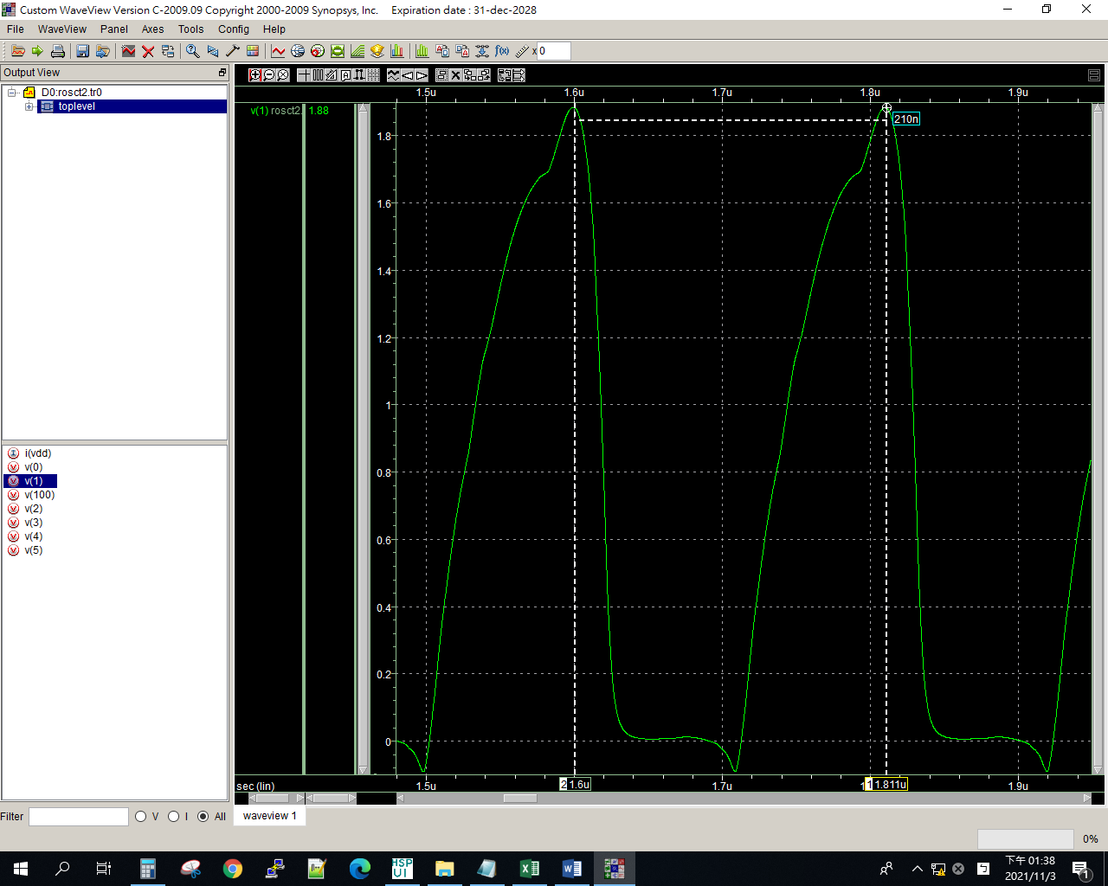

6u

ROSCT2

.lib "C:\synopsys\cic018.l" tt

.SUBCKT INV 10 20 100 99

M1 20 10 100 100 P_18 W=2U L=2U

M2 20 10 99 99 N_18 W=2U L=2U

.ENDS INV

.SUBCKT NAND A B Y 100 99

M1 Y A 100 100 P_18 W=1u L=2u

M2 Y B 100 100 P_18 W=1u L=2u

M3 Y B 1 99 N_18 W=2u L=2u

M4 1 A 99 99 N_18 W=2u L=2u

.ENDS NAND

.SUBCKT NOR A B Y 100 99

M1 1 A 100 100 P_18 W=2u L=6u

M2 Y B 1 100 P_18 W=2u L=6u

M3 Y A 99 99 N_18 W=1u L=6u

M4 Y B 99 99 N_18 W=1u L=6u

.ENDS NOR

Vdd 100 0 dc PWL(0 0 1us 0 1.1us 1.8v 2us 1.8v)

*X1 1 2 100 0 INV

*X2 2 3 100 0 INV

*X3 3 4 100 0 INV

*X4 4 5 100 0 INV

*X5 5 1 100 0 INV

*X1 1 1 2 100 0 NAND

*X2 2 2 3 100 0 NAND

*X3 3 3 4 100 0 NAND

*X4 4 4 5 100 0 NAND

*X5 5 5 1 100 0 NAND

X1 1 1 2 100 0 NOR

X2 2 2 3 100 0 NOR

X3 3 3 4 100 0 NOR

X4 4 4 5 100 0 NOR

X5 5 5 1 100 0 NOR

**analysis

.op

.option post

.tran 1ps 10us 0 0.1ns

.probe

.end

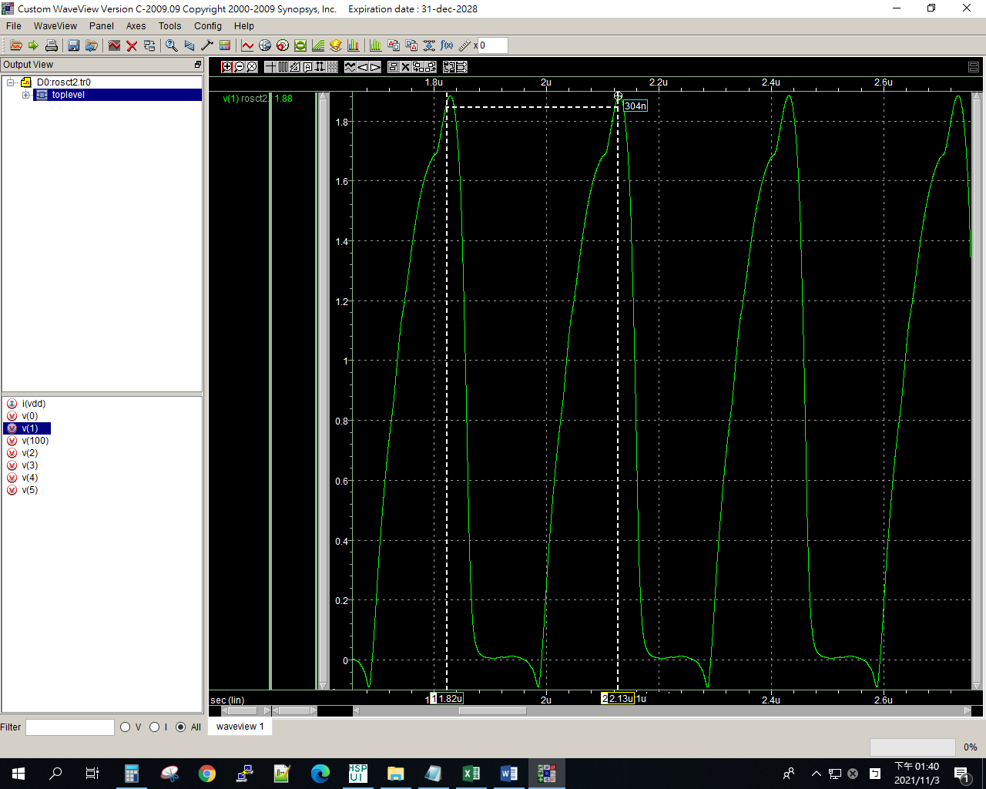

7u

ROSCT2

.lib "C:\synopsys\cic018.l" tt

.SUBCKT INV 10 20 100 99

M1 20 10 100 100 P_18 W=2U L=2U

M2 20 10 99 99 N_18 W=2U L=2U

.ENDS INV

.SUBCKT NAND A B Y 100 99

M1 Y A 100 100 P_18 W=1u L=2u

M2 Y B 100 100 P_18 W=1u L=2u

M3 Y B 1 99 N_18 W=2u L=2u

M4 1 A 99 99 N_18 W=2u L=2u

.ENDS NAND

.SUBCKT NOR A B Y 100 99

M1 1 A 100 100 P_18 W=2u L=7u

M2 Y B 1 100 P_18 W=2u L=7u

M3 Y A 99 99 N_18 W=1u L=7u

M4 Y B 99 99 N_18 W=1u L=7u

.ENDS NOR

Vdd 100 0 dc PWL(0 0 1us 0 1.1us 1.8v 2us 1.8v)

*X1 1 2 100 0 INV

*X2 2 3 100 0 INV

*X3 3 4 100 0 INV

*X4 4 5 100 0 INV

*X5 5 1 100 0 INV

*X1 1 1 2 100 0 NAND

*X2 2 2 3 100 0 NAND

*X3 3 3 4 100 0 NAND

*X4 4 4 5 100 0 NAND

*X5 5 5 1 100 0 NAND

X1 1 1 2 100 0 NOR

X2 2 2 3 100 0 NOR

X3 3 3 4 100 0 NOR

X4 4 4 5 100 0 NOR

X5 5 5 1 100 0 NOR

**analysis

.op

.option post

.tran 1ps 10us 0 0.1ns

.probe

.end

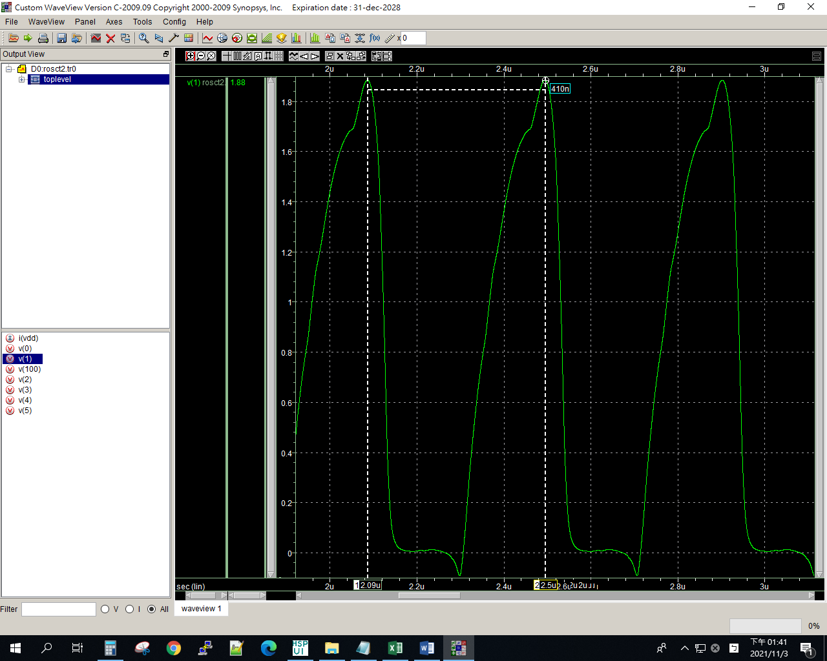

8u

ROSCT2

.lib "C:\synopsys\cic018.l" tt

.SUBCKT INV 10 20 100 99

M1 20 10 100 100 P_18 W=2U L=2U

M2 20 10 99 99 N_18 W=2U L=2U

.ENDS INV

.SUBCKT NAND A B Y 100 99

M1 Y A 100 100 P_18 W=1u L=2u

M2 Y B 100 100 P_18 W=1u L=2u

M3 Y B 1 99 N_18 W=2u L=2u

M4 1 A 99 99 N_18 W=2u L=2u

.ENDS NAND

.SUBCKT NOR A B Y 100 99

M1 1 A 100 100 P_18 W=2u L=8u

M2 Y B 1 100 P_18 W=2u L=8u

M3 Y A 99 99 N_18 W=1u L=8u

M4 Y B 99 99 N_18 W=1u L=8u

.ENDS NOR

Vdd 100 0 dc PWL(0 0 1us 0 1.1us 1.8v 2us 1.8v)

*X1 1 2 100 0 INV

*X2 2 3 100 0 INV

*X3 3 4 100 0 INV

*X4 4 5 100 0 INV

*X5 5 1 100 0 INV

*X1 1 1 2 100 0 NAND

*X2 2 2 3 100 0 NAND

*X3 3 3 4 100 0 NAND

*X4 4 4 5 100 0 NAND

*X5 5 5 1 100 0 NAND

X1 1 1 2 100 0 NOR

X2 2 2 3 100 0 NOR

X3 3 3 4 100 0 NOR

X4 4 4 5 100 0 NOR

X5 5 5 1 100 0 NOR

**analysis

.op

.option post

.tran 1ps 10us 0 0.1ns

.probe

.end

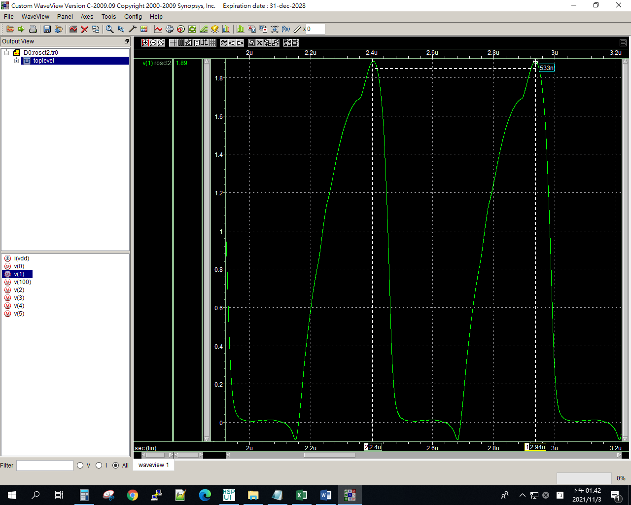

9u

ROSCT2

.lib "C:\synopsys\cic018.l" tt

.SUBCKT INV 10 20 100 99

M1 20 10 100 100 P_18 W=2U L=2U

M2 20 10 99 99 N_18 W=2U L=2U

.ENDS INV

.SUBCKT NAND A B Y 100 99

M1 Y A 100 100 P_18 W=1u L=2u

M2 Y B 100 100 P_18 W=1u L=2u

M3 Y B 1 99 N_18 W=2u L=2u

M4 1 A 99 99 N_18 W=2u L=2u

.ENDS NAND

.SUBCKT NOR A B Y 100 99

M1 1 A 100 100 P_18 W=2u L=9u

M2 Y B 1 100 P_18 W=2u L=9u

M3 Y A 99 99 N_18 W=1u L=9u

M4 Y B 99 99 N_18 W=1u L=9u

.ENDS NOR

Vdd 100 0 dc PWL(0 0 1us 0 1.1us 1.8v 2us 1.8v)

*X1 1 2 100 0 INV

*X2 2 3 100 0 INV

*X3 3 4 100 0 INV

*X4 4 5 100 0 INV

*X5 5 1 100 0 INV

*X1 1 1 2 100 0 NAND

*X2 2 2 3 100 0 NAND

*X3 3 3 4 100 0 NAND

*X4 4 4 5 100 0 NAND

*X5 5 5 1 100 0 NAND

X1 1 1 2 100 0 NOR

X2 2 2 3 100 0 NOR

X3 3 3 4 100 0 NOR

X4 4 4 5 100 0 NOR

X5 5 5 1 100 0 NOR

**analysis

.op

.option post

.tran 1ps 10us 0 0.1ns

.probe

.end

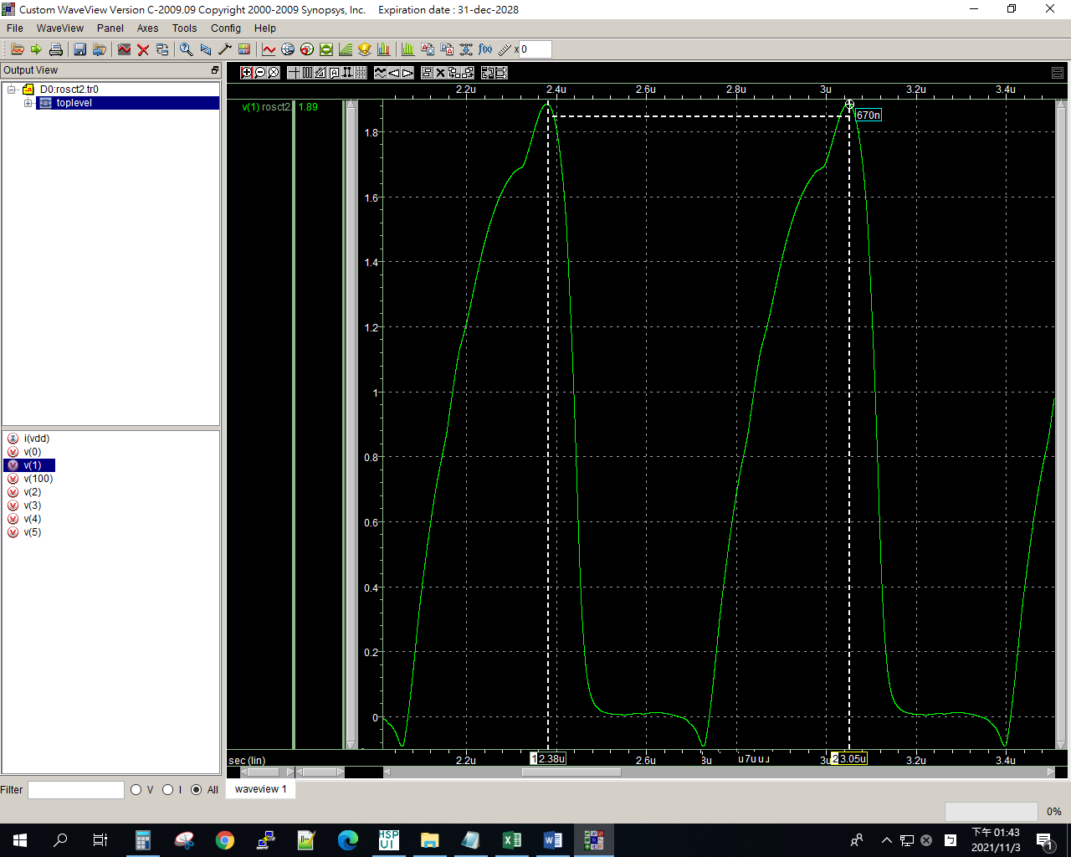

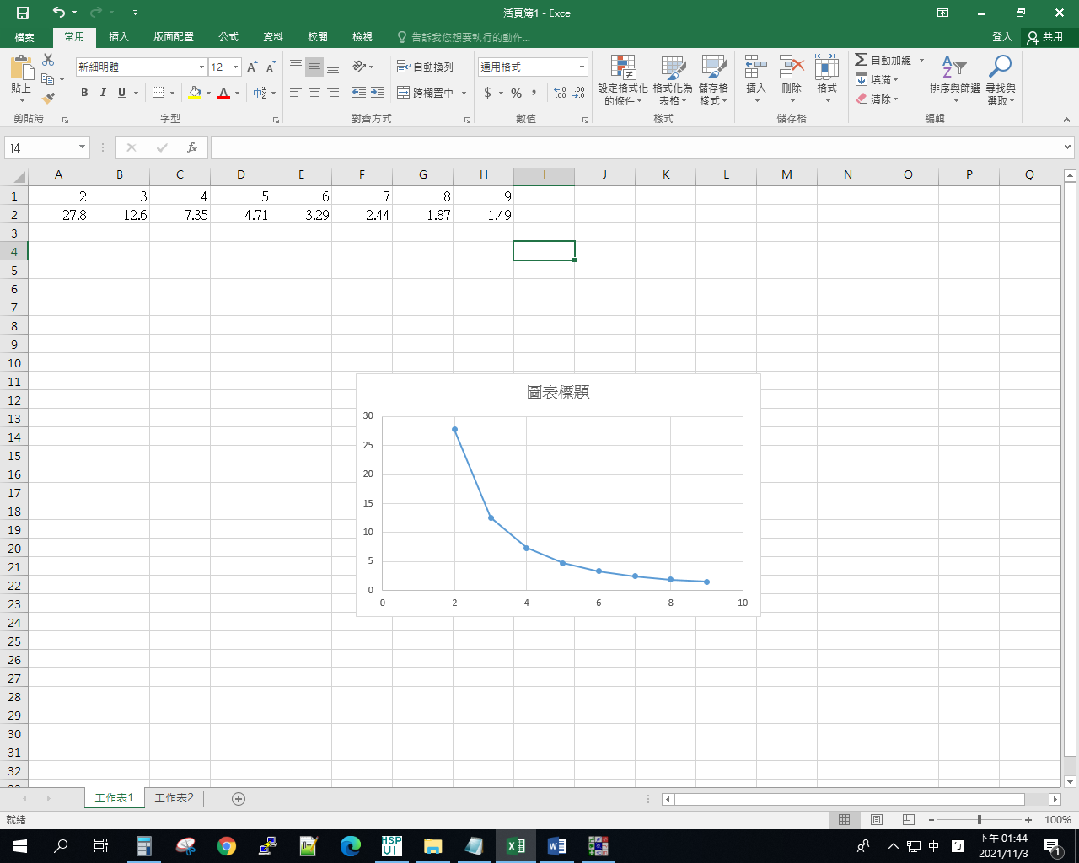

Lab7 rosct3

1u

ROSCT3

.lib "C:\synopsys\cic018.l" tt

.SUBCKT INV 10 20 100 99

M1 20 10 100 100 P_18 W=2U L=2U

M2 20 10 99 99 N_18 W=2U L=2U

.ENDS INV

.SUBCKT NAND A B Y 100 99

M1 Y A 100 100 P_18 W=1u L=2u

M2 Y B 100 100 P_18 W=1u L=2u

M3 Y B 1 99 N_18 W=2u L=2u

M4 1 A 99 99 N_18 W=2u L=2u

.ENDS NAND

.SUBCKT NOR A B Y 100 99

M1 1 A 100 100 P_18 W=2u L=2u

M2 Y B 1 100 P_18 W=2u L=2u

M3 Y A 99 99 N_18 W=1u L=2u

M4 Y B 99 99 N_18 W=1u L=2u

.ENDS NOR

Vdd 100 0 dc PWL(0 0 1us 0 1.1us 1.8v 2us 1.8v)

*X1 1 2 100 0 INV

*X2 2 3 100 0 INV

*X3 3 4 100 0 INV

*X4 4 5 100 0 INV

*X5 5 1 100 0 INV

*X1 1 1 2 100 0 NAND

*X2 2 2 3 100 0 NAND

*X3 3 3 4 100 0 NAND

*X4 4 4 5 100 0 NAND

*X5 5 5 1 100 0 NAND

X1 1 1 2 100 0 NOR

X2 2 2 3 100 0 NOR

X3 3 3 4 100 0 NOR

X4 4 4 5 100 0 NOR

X5 5 5 1 100 0 NOR

**analysis

.op

.option post

.tran 1ps 10us 0 0.1ns

.probe

.end

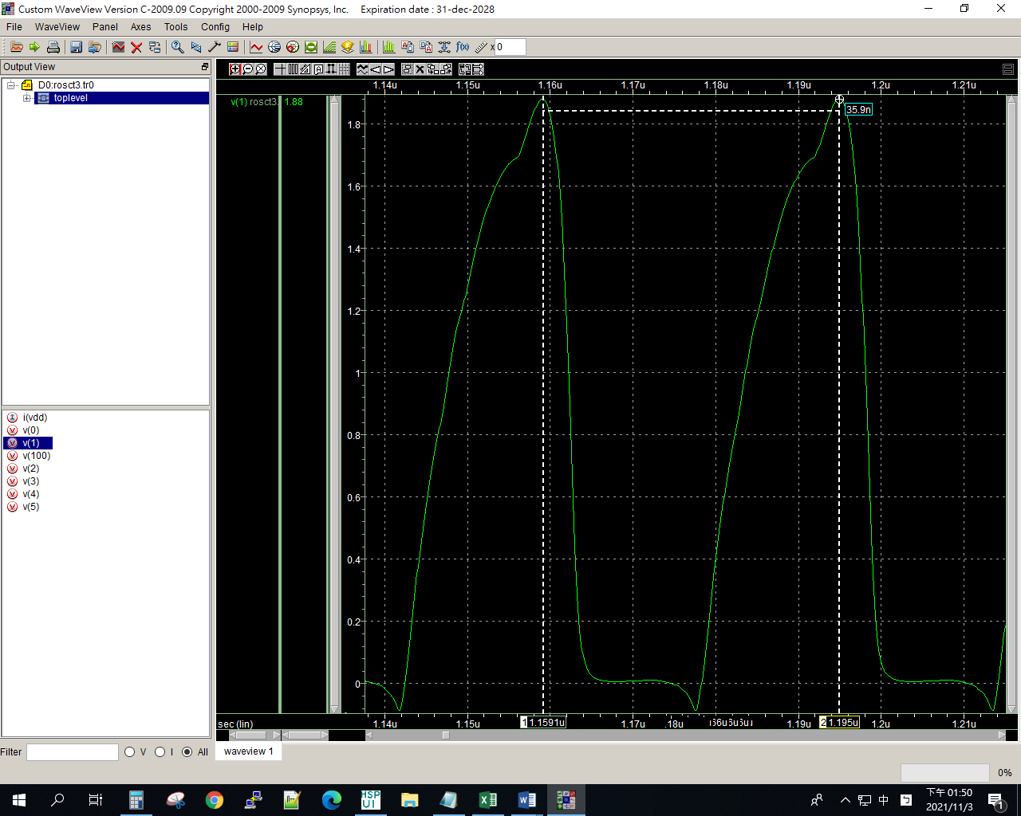

2u

ROSCT3

.lib "C:\synopsys\cic018.l" tt

.SUBCKT INV 10 20 100 99

M1 20 10 100 100 P_18 W=2U L=2U

M2 20 10 99 99 N_18 W=2U L=2U

.ENDS INV

.SUBCKT NAND A B Y 100 99

M1 Y A 100 100 P_18 W=1u L=2u

M2 Y B 100 100 P_18 W=1u L=2u

M3 Y B 1 99 N_18 W=2u L=2u

M4 1 A 99 99 N_18 W=2u L=2u

.ENDS NAND

.SUBCKT NOR A B Y 100 99

M1 1 A 100 100 P_18 W=4u L=2u

M2 Y B 1 100 P_18 W=4u L=2u

M3 Y A 99 99 N_18 W=2u L=2u

M4 Y B 99 99 N_18 W=2u L=2u

.ENDS NOR

Vdd 100 0 dc PWL(0 0 1us 0 1.1us 1.8v 2us 1.8v)

*X1 1 2 100 0 INV

*X2 2 3 100 0 INV

*X3 3 4 100 0 INV

*X4 4 5 100 0 INV

*X5 5 1 100 0 INV

*X1 1 1 2 100 0 NAND

*X2 2 2 3 100 0 NAND

*X3 3 3 4 100 0 NAND

*X4 4 4 5 100 0 NAND

*X5 5 5 1 100 0 NAND

X1 1 1 2 100 0 NOR

X2 2 2 3 100 0 NOR

X3 3 3 4 100 0 NOR

X4 4 4 5 100 0 NOR

X5 5 5 1 100 0 NOR

**analysis

.op

.option post

.tran 1ps 10us 0 0.1ns

.probe

.end

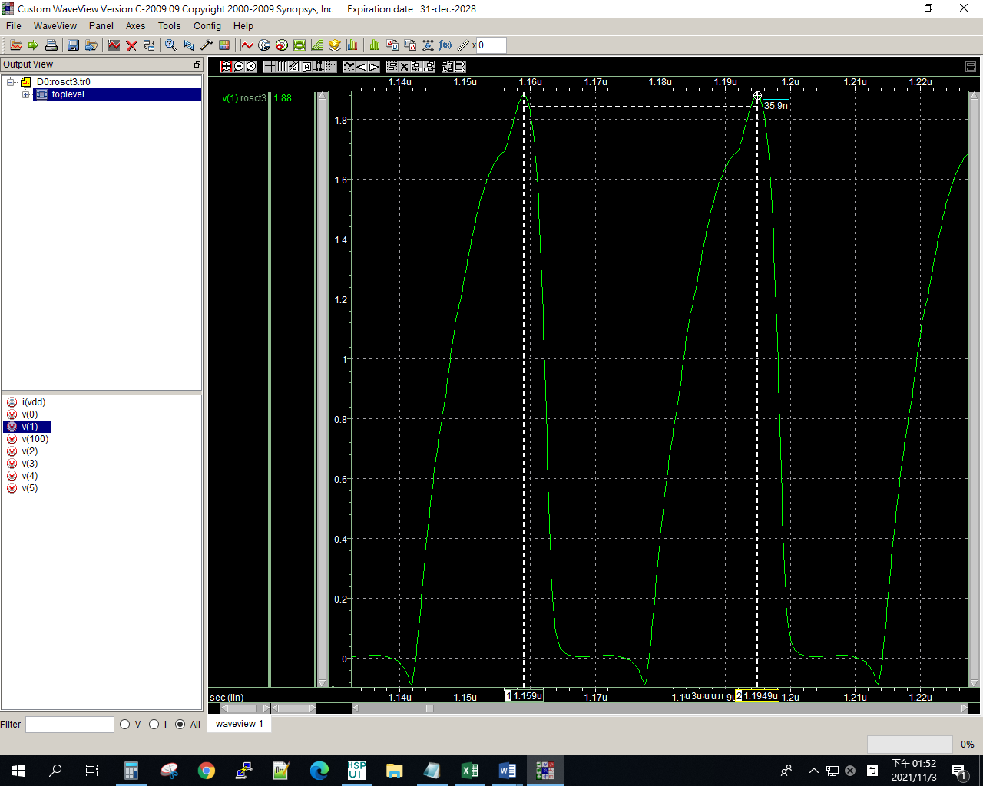

3u

ROSCT3

.lib "C:\synopsys\cic018.l" tt

.SUBCKT INV 10 20 100 99

M1 20 10 100 100 P_18 W=2U L=2U

M2 20 10 99 99 N_18 W=2U L=2U

.ENDS INV

.SUBCKT NAND A B Y 100 99

M1 Y A 100 100 P_18 W=1u L=2u

M2 Y B 100 100 P_18 W=1u L=2u

M3 Y B 1 99 N_18 W=2u L=2u

M4 1 A 99 99 N_18 W=2u L=2u

.ENDS NAND

.SUBCKT NOR A B Y 100 99

M1 1 A 100 100 P_18 W=6u L=2u

M2 Y B 1 100 P_18 W=6u L=2u

M3 Y A 99 99 N_18 W=3u L=2u

M4 Y B 99 99 N_18 W=3u L=2u

.ENDS NOR

Vdd 100 0 dc PWL(0 0 1us 0 1.1us 1.8v 2us 1.8v)

*X1 1 2 100 0 INV

*X2 2 3 100 0 INV

*X3 3 4 100 0 INV

*X4 4 5 100 0 INV

*X5 5 1 100 0 INV

*X1 1 1 2 100 0 NAND

*X2 2 2 3 100 0 NAND

*X3 3 3 4 100 0 NAND

*X4 4 4 5 100 0 NAND

*X5 5 5 1 100 0 NAND

X1 1 1 2 100 0 NOR

X2 2 2 3 100 0 NOR

X3 3 3 4 100 0 NOR

X4 4 4 5 100 0 NOR

X5 5 5 1 100 0 NOR

**analysis

.op

.option post

.tran 1ps 10us 0 0.1ns

.probe

.end

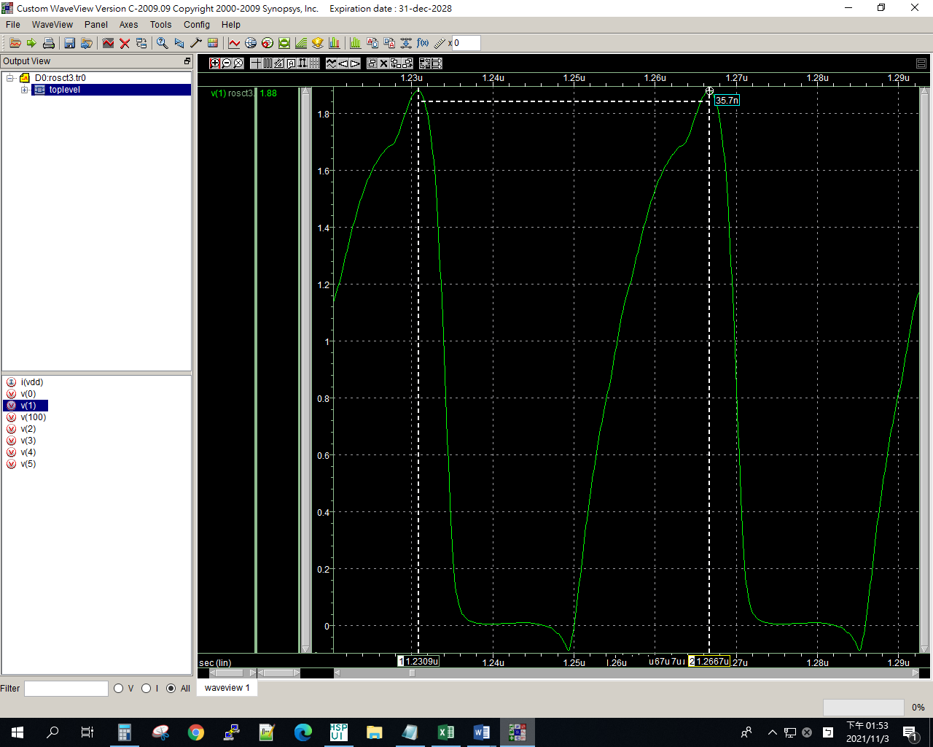

4u

ROSCT3

.lib "C:\synopsys\cic018.l" tt

.SUBCKT INV 10 20 100 99

M1 20 10 100 100 P_18 W=2U L=2U

M2 20 10 99 99 N_18 W=2U L=2U

.ENDS INV

.SUBCKT NAND A B Y 100 99

M1 Y A 100 100 P_18 W=1u L=2u

M2 Y B 100 100 P_18 W=1u L=2u

M3 Y B 1 99 N_18 W=2u L=2u

M4 1 A 99 99 N_18 W=2u L=2u

.ENDS NAND

.SUBCKT NOR A B Y 100 99

M1 1 A 100 100 P_18 W=8u L=2u

M2 Y B 1 100 P_18 W=8u L=2u

M3 Y A 99 99 N_18 W=4u L=2u

M4 Y B 99 99 N_18 W=4u L=2u

.ENDS NOR

Vdd 100 0 dc PWL(0 0 1us 0 1.1us 1.8v 2us 1.8v)

*X1 1 2 100 0 INV

*X2 2 3 100 0 INV

*X3 3 4 100 0 INV

*X4 4 5 100 0 INV

*X5 5 1 100 0 INV

*X1 1 1 2 100 0 NAND

*X2 2 2 3 100 0 NAND

*X3 3 3 4 100 0 NAND

*X4 4 4 5 100 0 NAND

*X5 5 5 1 100 0 NAND

X1 1 1 2 100 0 NOR

X2 2 2 3 100 0 NOR

X3 3 3 4 100 0 NOR

X4 4 4 5 100 0 NOR

X5 5 5 1 100 0 NOR

**analysis

.op

.option post

.tran 1ps 10us 0 0.1ns

.probe

.end

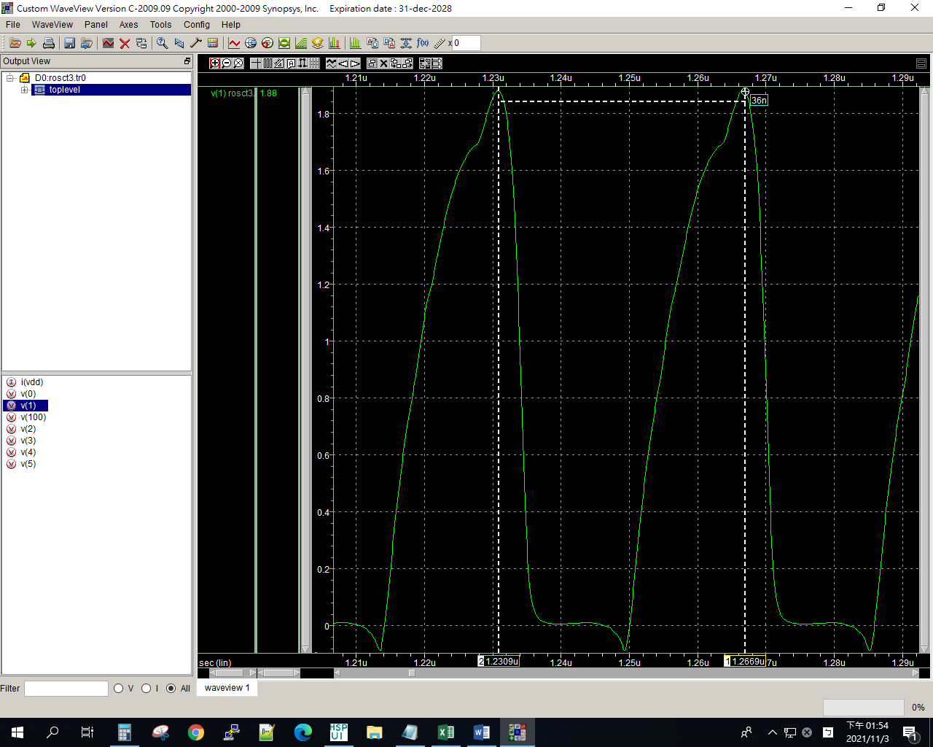

5u

ROSCT3

.lib "C:\synopsys\cic018.l" tt

.SUBCKT INV 10 20 100 99

M1 20 10 100 100 P_18 W=2U L=2U

M2 20 10 99 99 N_18 W=2U L=2U

.ENDS INV

.SUBCKT NAND A B Y 100 99

M1 Y A 100 100 P_18 W=1u L=2u

M2 Y B 100 100 P_18 W=1u L=2u

M3 Y B 1 99 N_18 W=2u L=2u

M4 1 A 99 99 N_18 W=2u L=2u

.ENDS NAND

.SUBCKT NOR A B Y 100 99

M1 1 A 100 100 P_18 W=10u L=2u

M2 Y B 1 100 P_18 W=10u L=2u

M3 Y A 99 99 N_18 W=5u L=2u

M4 Y B 99 99 N_18 W=5u L=2u

.ENDS NOR

Vdd 100 0 dc PWL(0 0 1us 0 1.1us 1.8v 2us 1.8v)

*X1 1 2 100 0 INV

*X2 2 3 100 0 INV

*X3 3 4 100 0 INV

*X4 4 5 100 0 INV

*X5 5 1 100 0 INV

*X1 1 1 2 100 0 NAND

*X2 2 2 3 100 0 NAND

*X3 3 3 4 100 0 NAND

*X4 4 4 5 100 0 NAND

*X5 5 5 1 100 0 NAND

X1 1 1 2 100 0 NOR

X2 2 2 3 100 0 NOR

X3 3 3 4 100 0 NOR

X4 4 4 5 100 0 NOR

X5 5 5 1 100 0 NOR

**analysis

.op

.option post

.tran 1ps 10us 0 0.1ns

.probe

.end

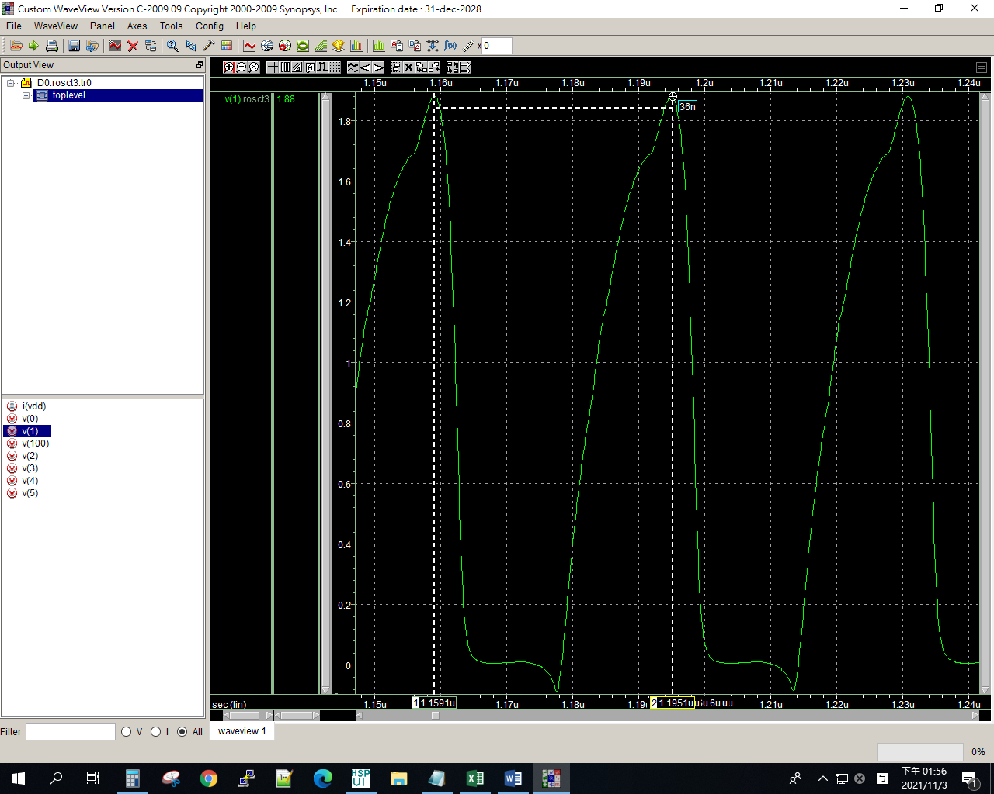

6u

ROSCT3

.lib "C:\synopsys\cic018.l" tt

.SUBCKT INV 10 20 100 99

M1 20 10 100 100 P_18 W=2U L=2U

M2 20 10 99 99 N_18 W=2U L=2U

.ENDS INV

.SUBCKT NAND A B Y 100 99

M1 Y A 100 100 P_18 W=1u L=2u

M2 Y B 100 100 P_18 W=1u L=2u

M3 Y B 1 99 N_18 W=2u L=2u

M4 1 A 99 99 N_18 W=2u L=2u

.ENDS NAND

.SUBCKT NOR A B Y 100 99

M1 1 A 100 100 P_18 W=12u L=2u

M2 Y B 1 100 P_18 W=12u L=2u

M3 Y A 99 99 N_18 W=6u L=2u

M4 Y B 99 99 N_18 W=6u L=2u

.ENDS NOR

Vdd 100 0 dc PWL(0 0 1us 0 1.1us 1.8v 2us 1.8v)

*X1 1 2 100 0 INV

*X2 2 3 100 0 INV

*X3 3 4 100 0 INV

*X4 4 5 100 0 INV

*X5 5 1 100 0 INV

*X1 1 1 2 100 0 NAND

*X2 2 2 3 100 0 NAND

*X3 3 3 4 100 0 NAND

*X4 4 4 5 100 0 NAND

*X5 5 5 1 100 0 NAND

X1 1 1 2 100 0 NOR

X2 2 2 3 100 0 NOR

X3 3 3 4 100 0 NOR

X4 4 4 5 100 0 NOR

X5 5 5 1 100 0 NOR

**analysis

.op

.option post

.tran 1ps 10us 0 0.1ns

.probe

.end

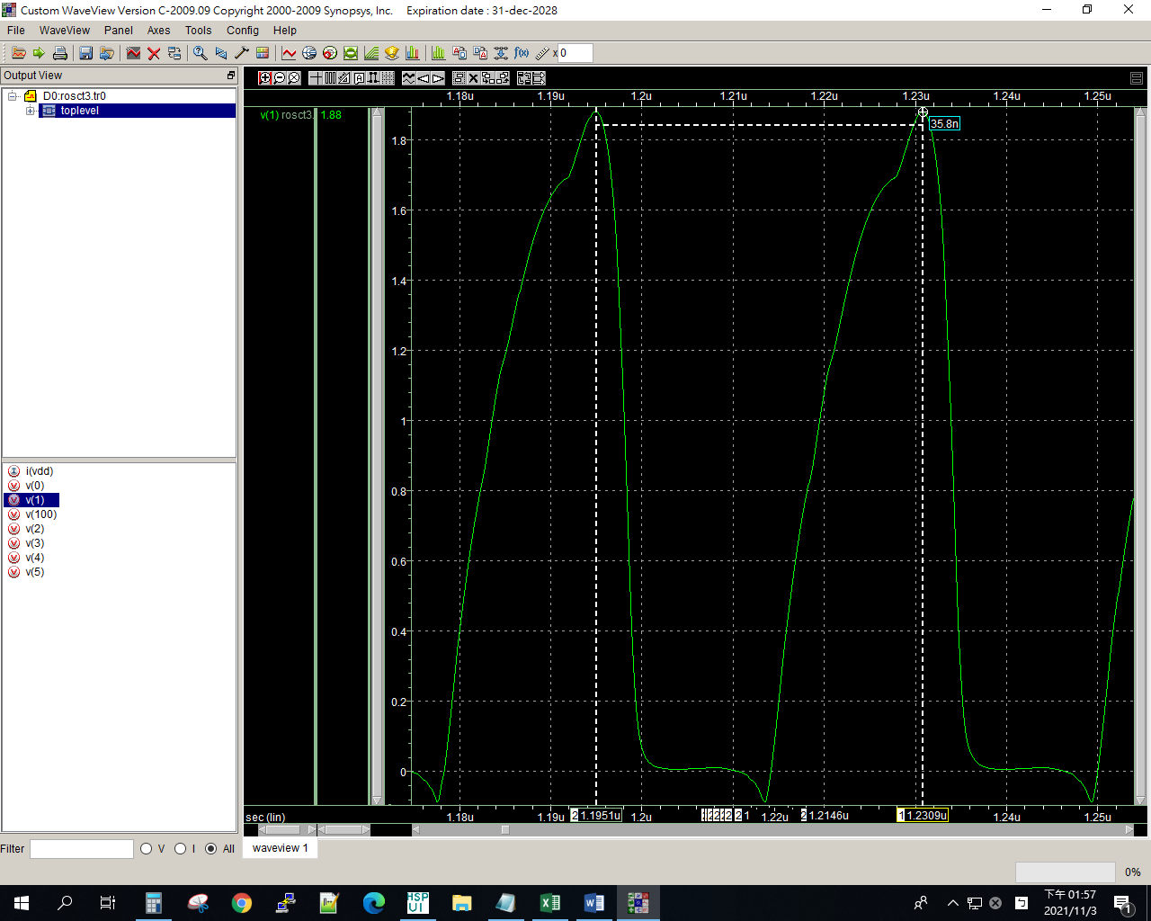

7u

ROSCT3

.lib "C:\synopsys\cic018.l" tt

.SUBCKT INV 10 20 100 99

M1 20 10 100 100 P_18 W=2U L=2U

M2 20 10 99 99 N_18 W=2U L=2U

.ENDS INV

.SUBCKT NAND A B Y 100 99

M1 Y A 100 100 P_18 W=1u L=2u

M2 Y B 100 100 P_18 W=1u L=2u

M3 Y B 1 99 N_18 W=2u L=2u

M4 1 A 99 99 N_18 W=2u L=2u

.ENDS NAND

.SUBCKT NOR A B Y 100 99

M1 1 A 100 100 P_18 W=14u L=2u

M2 Y B 1 100 P_18 W=14u L=2u

M3 Y A 99 99 N_18 W=7u L=2u

M4 Y B 99 99 N_18 W=7u L=2u

.ENDS NOR

Vdd 100 0 dc PWL(0 0 1us 0 1.1us 1.8v 2us 1.8v)

*X1 1 2 100 0 INV

*X2 2 3 100 0 INV

*X3 3 4 100 0 INV

*X4 4 5 100 0 INV

*X5 5 1 100 0 INV

*X1 1 1 2 100 0 NAND

*X2 2 2 3 100 0 NAND

*X3 3 3 4 100 0 NAND

*X4 4 4 5 100 0 NAND

*X5 5 5 1 100 0 NAND

X1 1 1 2 100 0 NOR

X2 2 2 3 100 0 NOR

X3 3 3 4 100 0 NOR

X4 4 4 5 100 0 NOR

X5 5 5 1 100 0 NOR

**analysis

.op

.option post

.tran 1ps 10us 0 0.1ns

.probe

.end

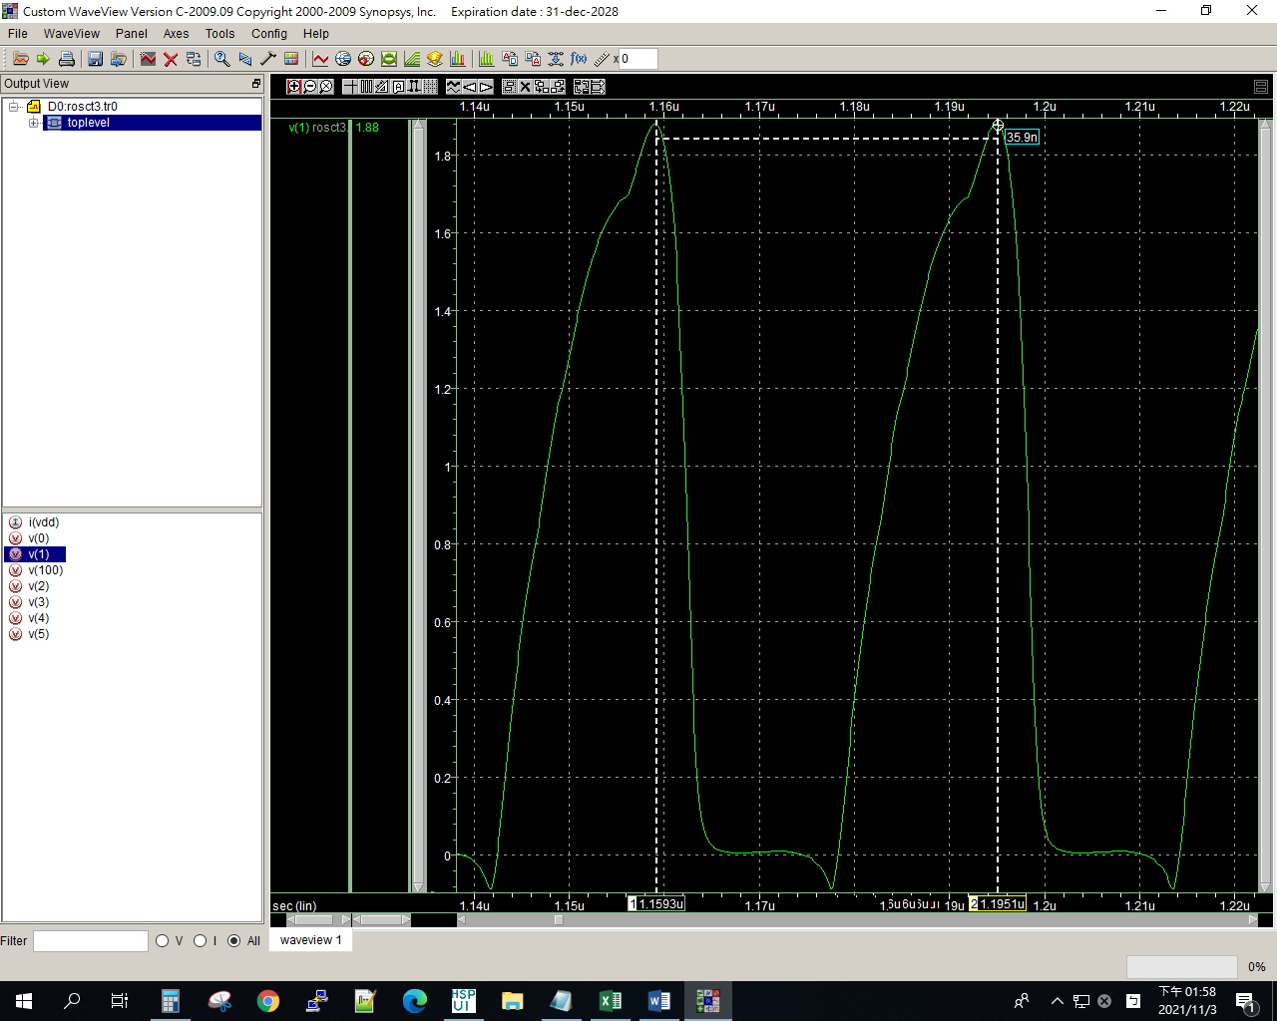

8u

ROSCT3

.lib "C:\synopsys\cic018.l" tt

.SUBCKT INV 10 20 100 99

M1 20 10 100 100 P_18 W=2U L=2U

M2 20 10 99 99 N_18 W=2U L=2U

.ENDS INV

.SUBCKT NAND A B Y 100 99

M1 Y A 100 100 P_18 W=1u L=2u

M2 Y B 100 100 P_18 W=1u L=2u

M3 Y B 1 99 N_18 W=2u L=2u

M4 1 A 99 99 N_18 W=2u L=2u

.ENDS NAND

.SUBCKT NOR A B Y 100 99

M1 1 A 100 100 P_18 W=16u L=2u

M2 Y B 1 100 P_18 W=16u L=2u

M3 Y A 99 99 N_18 W=8u L=2u

M4 Y B 99 99 N_18 W=8u L=2u

.ENDS NOR

Vdd 100 0 dc PWL(0 0 1us 0 1.1us 1.8v 2us 1.8v)

*X1 1 2 100 0 INV

*X2 2 3 100 0 INV

*X3 3 4 100 0 INV

*X4 4 5 100 0 INV

*X5 5 1 100 0 INV

*X1 1 1 2 100 0 NAND

*X2 2 2 3 100 0 NAND

*X3 3 3 4 100 0 NAND

*X4 4 4 5 100 0 NAND

*X5 5 5 1 100 0 NAND

X1 1 1 2 100 0 NOR

X2 2 2 3 100 0 NOR

X3 3 3 4 100 0 NOR

X4 4 4 5 100 0 NOR

X5 5 5 1 100 0 NOR

**analysis

.op

.option post

.tran 1ps 10us 0 0.1ns

.probe

.end

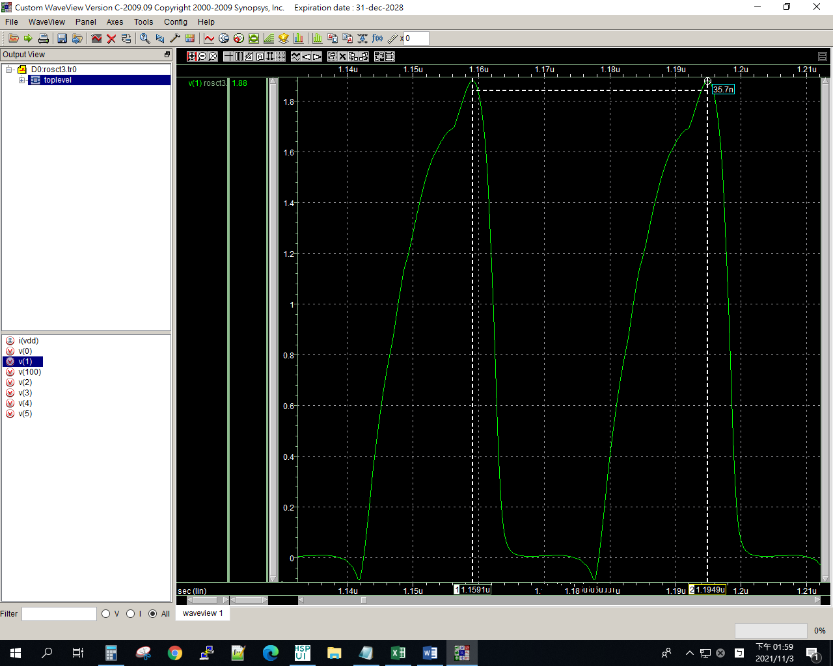

9u

ROSCT3

.lib "C:\synopsys\cic018.l" tt

.SUBCKT INV 10 20 100 99

M1 20 10 100 100 P_18 W=2U L=2U

M2 20 10 99 99 N_18 W=2U L=2U

.ENDS INV

.SUBCKT NAND A B Y 100 99

M1 Y A 100 100 P_18 W=1u L=2u

M2 Y B 100 100 P_18 W=1u L=2u

M3 Y B 1 99 N_18 W=2u L=2u

M4 1 A 99 99 N_18 W=2u L=2u

.ENDS NAND

.SUBCKT NOR A B Y 100 99

M1 1 A 100 100 P_18 W=18u L=2u

M2 Y B 1 100 P_18 W=18u L=2u

M3 Y A 99 99 N_18 W=9u L=2u

M4 Y B 99 99 N_18 W=9u L=2u

.ENDS NOR

Vdd 100 0 dc PWL(0 0 1us 0 1.1us 1.8v 2us 1.8v)

*X1 1 2 100 0 INV

*X2 2 3 100 0 INV

*X3 3 4 100 0 INV

*X4 4 5 100 0 INV

*X5 5 1 100 0 INV

*X1 1 1 2 100 0 NAND

*X2 2 2 3 100 0 NAND

*X3 3 3 4 100 0 NAND

*X4 4 4 5 100 0 NAND

*X5 5 5 1 100 0 NAND

X1 1 1 2 100 0 NOR

X2 2 2 3 100 0 NOR

X3 3 3 4 100 0 NOR

X4 4 4 5 100 0 NOR

X5 5 5 1 100 0 NOR

**analysis

.op

.option post

.tran 1ps 10us 0 0.1ns

.probe

.end

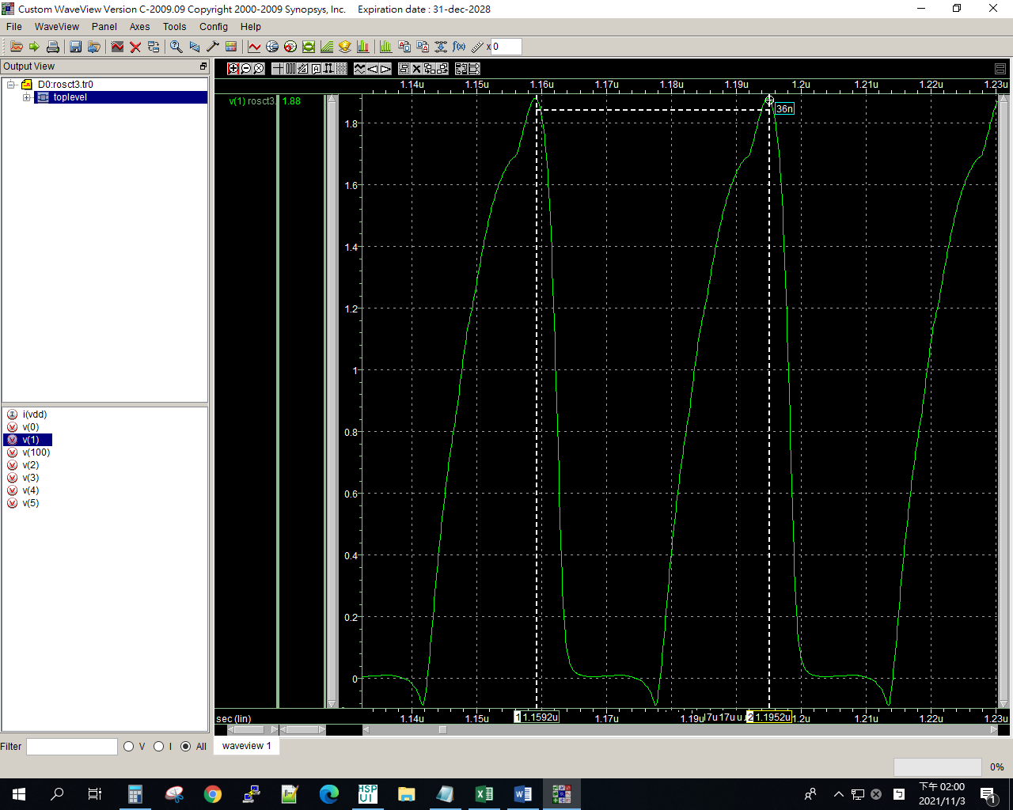

10u

ROSCT3

.lib "C:\synopsys\cic018.l" tt

.SUBCKT INV 10 20 100 99

M1 20 10 100 100 P_18 W=2U L=2U

M2 20 10 99 99 N_18 W=2U L=2U

.ENDS INV

.SUBCKT NAND A B Y 100 99

M1 Y A 100 100 P_18 W=1u L=2u

M2 Y B 100 100 P_18 W=1u L=2u

M3 Y B 1 99 N_18 W=2u L=2u

M4 1 A 99 99 N_18 W=2u L=2u

.ENDS NAND

.SUBCKT NOR A B Y 100 99

M1 1 A 100 100 P_18 W=20u L=2u

M2 Y B 1 100 P_18 W=20u L=2u

M3 Y A 99 99 N_18 W=10u L=2u

M4 Y B 99 99 N_18 W=10u L=2u

.ENDS NOR

Vdd 100 0 dc PWL(0 0 1us 0 1.1us 1.8v 2us 1.8v)

*X1 1 2 100 0 INV

*X2 2 3 100 0 INV

*X3 3 4 100 0 INV

*X4 4 5 100 0 INV

*X5 5 1 100 0 INV

*X1 1 1 2 100 0 NAND

*X2 2 2 3 100 0 NAND

*X3 3 3 4 100 0 NAND

*X4 4 4 5 100 0 NAND

*X5 5 5 1 100 0 NAND

X1 1 1 2 100 0 NOR

X2 2 2 3 100 0 NOR

X3 3 3 4 100 0 NOR

X4 4 4 5 100 0 NOR

X5 5 5 1 100 0 NOR

**analysis

.op

.option post

.tran 1ps 10us 0 0.1ns

.probe

.end

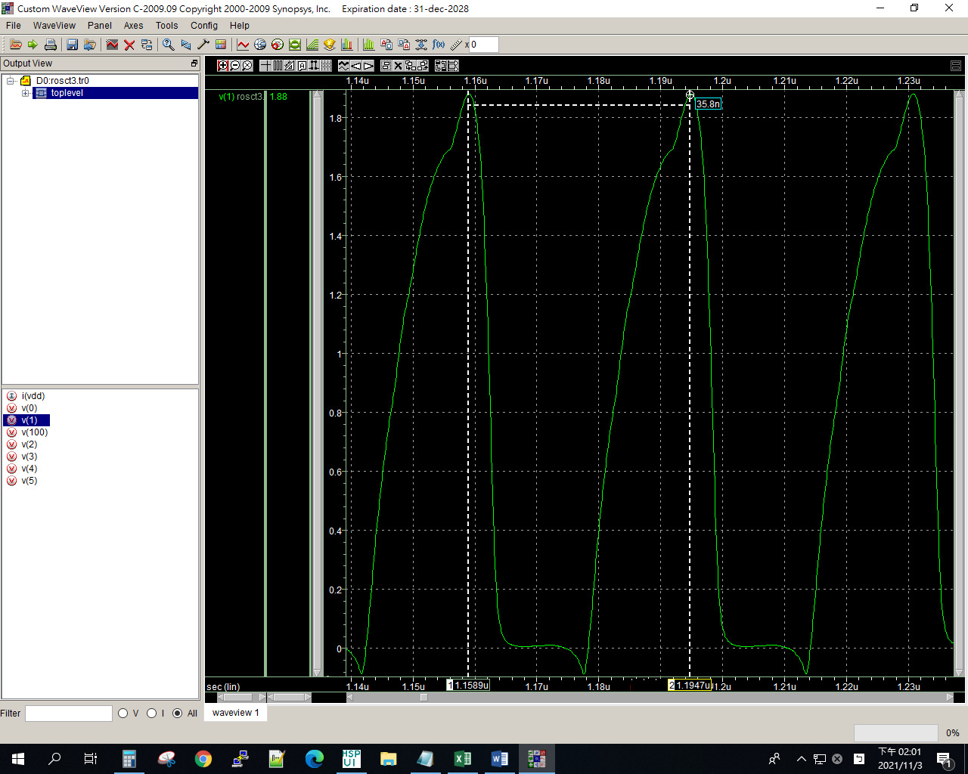

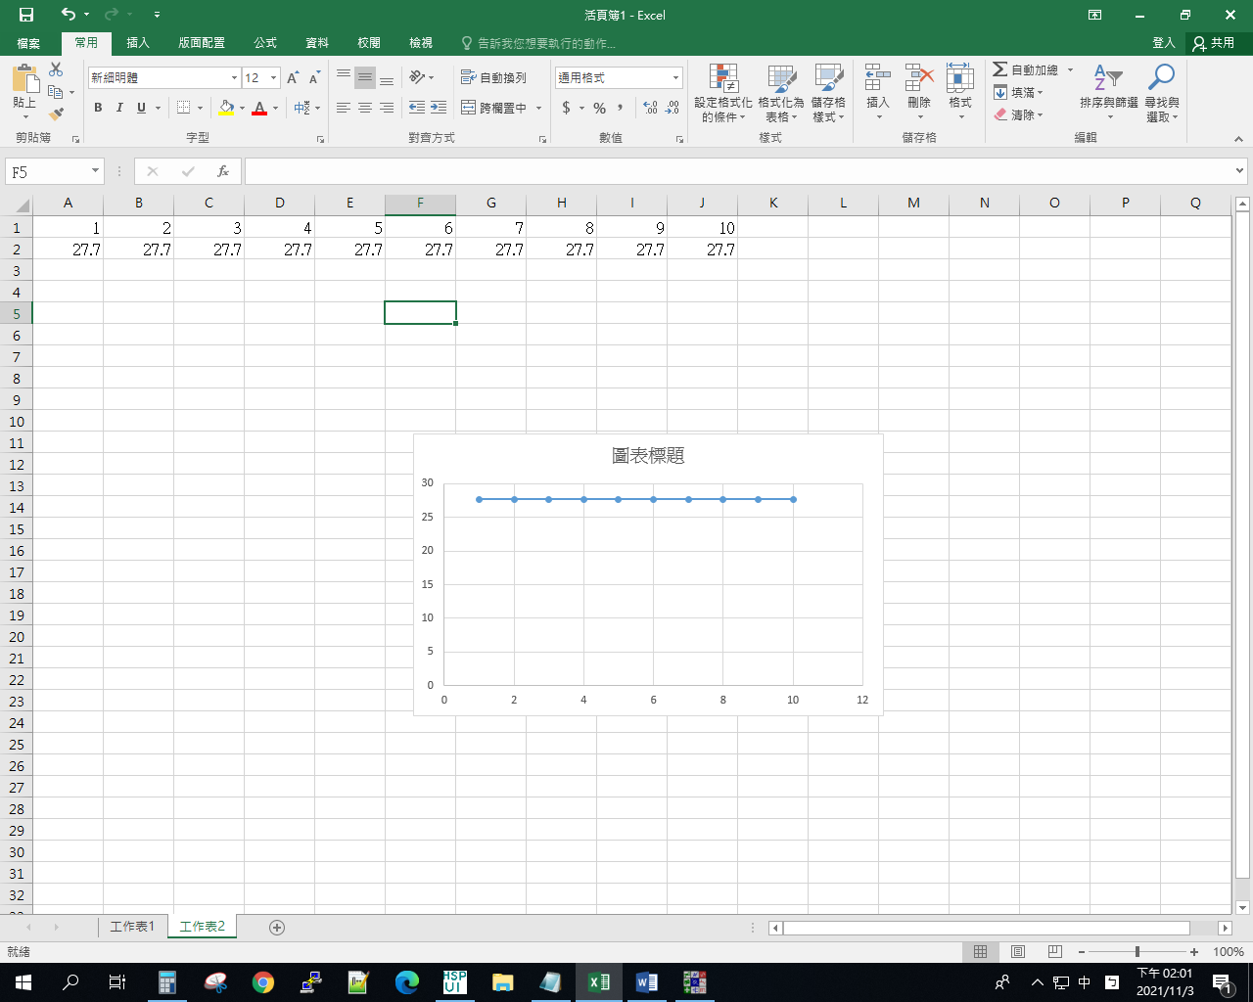

Lab8-Rosct4

1u

ROSCT

.lib "C:\synopsys\cic018.l" tt

.SUBCKT INV 10 20 100 99

M1 20 10 100 100 P_18 W=2U L=2U

M2 20 10 99 99 N_18 W=1U L=2U

.ENDS INV

.SUBCKT NAND A B Y 100 99

M1 Y A 100 100 P_18 W=2u L=2u

M2 Y B 100 100 P_18 W=2u L=2u

M3 Y B 1 99 N_18 W=4u L=2u

M4 1 A 99 99 N_18 W=4u L=2u

.ENDS NAND

.SUBCKT NOR A B Y 100 99

M1 1 A 100 100 P_18 W=2u L=2u

M2 Y B 1 100 P_18 W=2u L=2u

M3 Y A 99 99 N_18 W=1u L=2u

M4 Y B 99 99 N_18 W=1u L=2u

.ENDS NOR

Vdd 100 0 dc PWL(0 0 1us 0 1.1us 1.8v 2us 1.8v)

X1 1 2 101 98 INV

X2 2 3 101 98 INV

X3 3 4 101 98 INV

X4 4 5 101 98 INV

X5 5 1 101 98 INV

Mx1 20 20 100 100 P_18 W=2u L=0.2u

Mx2 21 21 0 0 N_18 W=1u L=0.2u

Mx3 101 20 100 100 P_18 W=2u L=0.2u

Mx4 98 21 0 0 N_18 W=1u L=0.2u

Ix1 20 21 DC 1uA

*X1 1 1 2 100 0 NAND

*X2 2 2 3 100 0 NAND

*X3 3 3 4 100 0 NAND

*X4 4 4 5 100 0 NAND

*X5 5 5 1 100 0 NAND

*X1 1 1 2 100 0 NOR

*X2 2 2 3 100 0 NOR

*X3 3 3 4 100 0 NOR

*X4 4 4 5 100 0 NOR

*X5 5 5 1 100 0 NOR

**analysis

.op

.option post

.tran 1ps 10us 0 0.1ns

.probe

.end

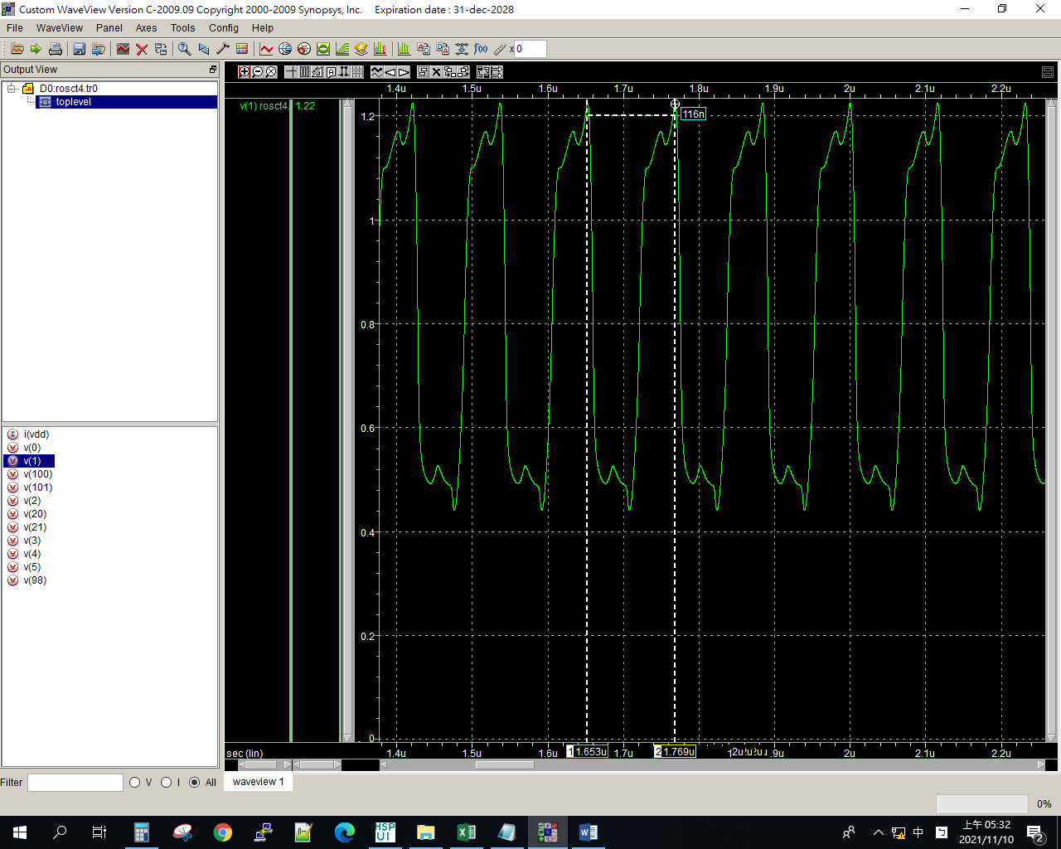

2u

ROSCT

.lib "C:\synopsys\cic018.l" tt

.SUBCKT INV 10 20 100 99

M1 20 10 100 100 P_18 W=2U L=2U

M2 20 10 99 99 N_18 W=1U L=2U

.ENDS INV

.SUBCKT NAND A B Y 100 99

M1 Y A 100 100 P_18 W=2u L=2u

M2 Y B 100 100 P_18 W=2u L=2u

M3 Y B 1 99 N_18 W=4u L=2u

M4 1 A 99 99 N_18 W=4u L=2u

.ENDS NAND

.SUBCKT NOR A B Y 100 99

M1 1 A 100 100 P_18 W=2u L=2u

M2 Y B 1 100 P_18 W=2u L=2u

M3 Y A 99 99 N_18 W=1u L=2u

M4 Y B 99 99 N_18 W=1u L=2u

.ENDS NOR

Vdd 100 0 dc PWL(0 0 1us 0 1.1us 1.8v 2us 1.8v)

X1 1 2 101 98 INV

X2 2 3 101 98 INV

X3 3 4 101 98 INV

X4 4 5 101 98 INV

X5 5 1 101 98 INV

Mx1 20 20 100 100 P_18 W=2u L=0.2u

Mx2 21 21 0 0 N_18 W=1u L=0.2u

Mx3 101 20 100 100 P_18 W=2u L=0.2u

Mx4 98 21 0 0 N_18 W=1u L=0.2u

Ix1 20 21 DC 2uA

*X1 1 1 2 100 0 NAND

*X2 2 2 3 100 0 NAND

*X3 3 3 4 100 0 NAND

*X4 4 4 5 100 0 NAND

*X5 5 5 1 100 0 NAND

*X1 1 1 2 100 0 NOR

*X2 2 2 3 100 0 NOR

*X3 3 3 4 100 0 NOR

*X4 4 4 5 100 0 NOR

*X5 5 5 1 100 0 NOR

**analysis

.op

.option post

.tran 1ps 10us 0 0.1ns

.probe

.end

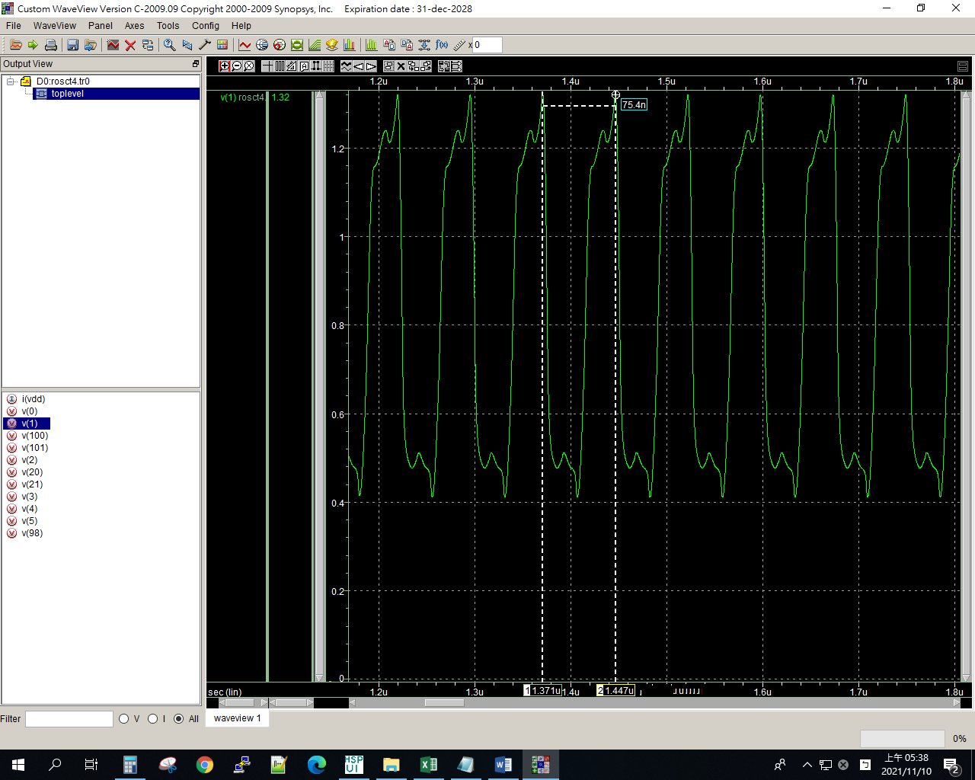

3u

ROSCT

.lib "C:\synopsys\cic018.l" tt

.SUBCKT INV 10 20 100 99

M1 20 10 100 100 P_18 W=2U L=2U

M2 20 10 99 99 N_18 W=1U L=2U

.ENDS INV

.SUBCKT NAND A B Y 100 99

M1 Y A 100 100 P_18 W=1u L=2u

M2 Y B 100 100 P_18 W=1u L=2u

M3 Y B 1 99 N_18 W=2u L=2u

M4 1 A 99 99 N_18 W=2u L=2u

.ENDS NAND

.SUBCKT NOR A B Y 100 99

M1 1 A 100 100 P_18 W=2u L=2u

M2 Y B 1 100 P_18 W=2u L=2u

M3 Y A 99 99 N_18 W=1u L=2u

M4 Y B 99 99 N_18 W=1u L=2u

.ENDS NOR

Vdd 100 0 dc PWL(0 0 1us 0 1.1us 1.8v 2us 1.8v)

X1 1 2 101 98 INV

X2 2 3 101 98 INV

X3 3 4 101 98 INV

X4 4 5 101 98 INV

X5 5 1 101 98 INV

Mx1 20 20 100 100 P_18 W=2u L=0.2u

Mx2 21 21 0 0 N_18 W=1u L=0.2u

Mx3 101 20 100 100 P_18 W=2u L=0.2u

Mx4 98 21 0 0 N_18 W=1u L=0.2u

Ix1 20 21 DC 3uA

*X1 1 1 2 100 0 NAND

*X2 2 2 3 100 0 NAND

*X3 3 3 4 100 0 NAND

*X4 4 4 5 100 0 NAND

*X5 5 5 1 100 0 NAND

*X1 1 1 2 100 0 NOR

*X2 2 2 3 100 0 NOR

*X3 3 3 4 100 0 NOR

*X4 4 4 5 100 0 NOR

*X5 5 5 1 100 0 NOR

**analysis

.op

.option post

.tran 1ps 10us 0 0.1ns

.probe

.end

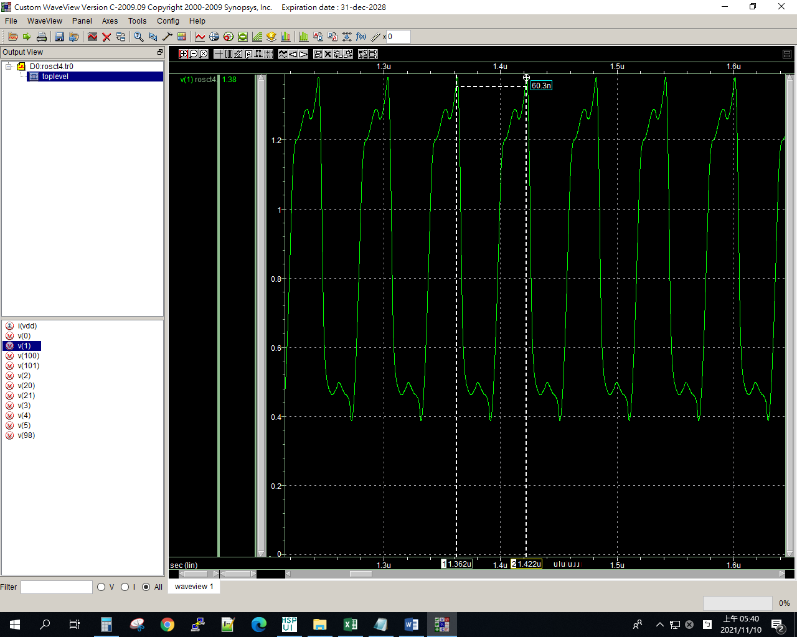

4u

ROSCT

.lib "C:\synopsys\cic018.l" tt

.SUBCKT INV 10 20 100 99

M1 20 10 100 100 P_18 W=2U L=2U

M2 20 10 99 99 N_18 W=1U L=2U

.ENDS INV

.SUBCKT NAND A B Y 100 99

M1 Y A 100 100 P_18 W=1u L=2u

M2 Y B 100 100 P_18 W=1u L=2u

M3 Y B 1 99 N_18 W=2u L=2u

M4 1 A 99 99 N_18 W=2u L=2u

.ENDS NAND

.SUBCKT NOR A B Y 100 99

M1 1 A 100 100 P_18 W=2u L=2u

M2 Y B 1 100 P_18 W=2u L=2u

M3 Y A 99 99 N_18 W=1u L=2u

M4 Y B 99 99 N_18 W=1u L=2u

.ENDS NOR

Vdd 100 0 dc PWL(0 0 1us 0 1.1us 1.8v 2us 1.8v)

X1 1 2 101 98 INV

X2 2 3 101 98 INV

X3 3 4 101 98 INV

X4 4 5 101 98 INV

X5 5 1 101 98 INV

Mx1 20 20 100 100 P_18 W=2u L=0.2u

Mx2 21 21 0 0 N_18 W=1u L=0.2u

Mx3 101 20 100 100 P_18 W=2u L=0.2u

Mx4 98 21 0 0 N_18 W=1u L=0.2u

Ix1 20 21 DC 4uA

*X1 1 1 2 100 0 NAND

*X2 2 2 3 100 0 NAND

*X3 3 3 4 100 0 NAND

*X4 4 4 5 100 0 NAND

*X5 5 5 1 100 0 NAND

*X1 1 1 2 100 0 NOR

*X2 2 2 3 100 0 NOR

*X3 3 3 4 100 0 NOR

*X4 4 4 5 100 0 NOR

*X5 5 5 1 100 0 NOR

**analysis

.op

.option post

.tran 1ps 10us 0 0.1ns

.probe

.end

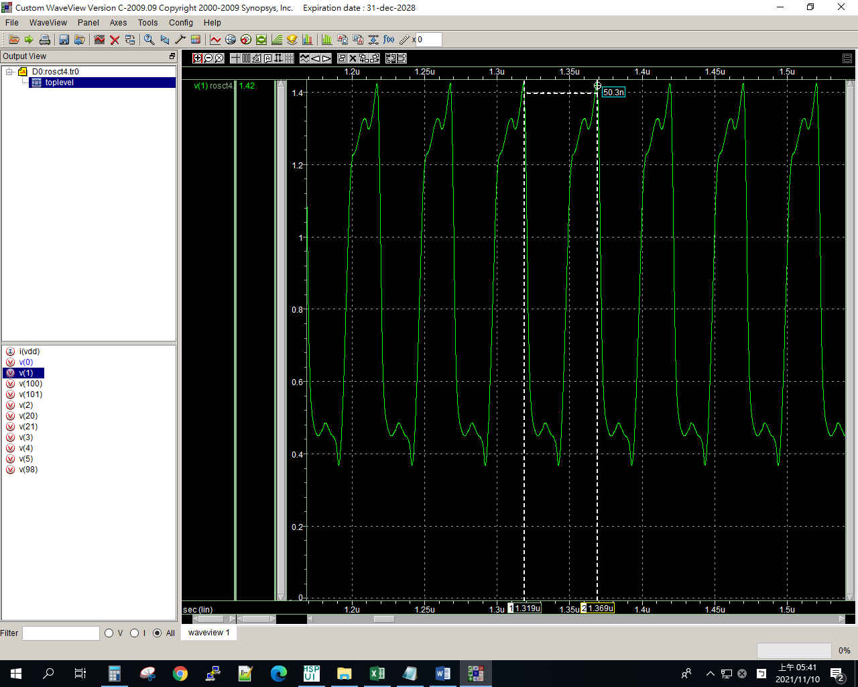

5u

ROSCT

.lib "C:\synopsys\cic018.l" tt

.SUBCKT INV 10 20 100 99

M1 20 10 100 100 P_18 W=2U L=2U

M2 20 10 99 99 N_18 W=1U L=2U

.ENDS INV

.SUBCKT NAND A B Y 100 99

M1 Y A 100 100 P_18 W=1u L=2u

M2 Y B 100 100 P_18 W=1u L=2u

M3 Y B 1 99 N_18 W=2u L=2u

M4 1 A 99 99 N_18 W=2u L=2u

.ENDS NAND

.SUBCKT NOR A B Y 100 99

M1 1 A 100 100 P_18 W=2u L=2u

M2 Y B 1 100 P_18 W=2u L=2u

M3 Y A 99 99 N_18 W=1u L=2u

M4 Y B 99 99 N_18 W=1u L=2u

.ENDS NOR

Vdd 100 0 dc PWL(0 0 1us 0 1.1us 1.8v 2us 1.8v)

X1 1 2 101 98 INV

X2 2 3 101 98 INV

X3 3 4 101 98 INV

X4 4 5 101 98 INV

X5 5 1 101 98 INV

Mx1 20 20 100 100 P_18 W=2u L=0.2u

Mx2 21 21 0 0 N_18 W=1u L=0.2u

Mx3 101 20 100 100 P_18 W=2u L=0.2u

Mx4 98 21 0 0 N_18 W=1u L=0.2u

Ix1 20 21 DC 5uA

*X1 1 1 2 100 0 NAND

*X2 2 2 3 100 0 NAND

*X3 3 3 4 100 0 NAND

*X4 4 4 5 100 0 NAND

*X5 5 5 1 100 0 NAND

*X1 1 1 2 100 0 NOR

*X2 2 2 3 100 0 NOR

*X3 3 3 4 100 0 NOR

*X4 4 4 5 100 0 NOR

*X5 5 5 1 100 0 NOR

**analysis

.op

.option post

.tran 1ps 10us 0 0.1ns

.probe

.end

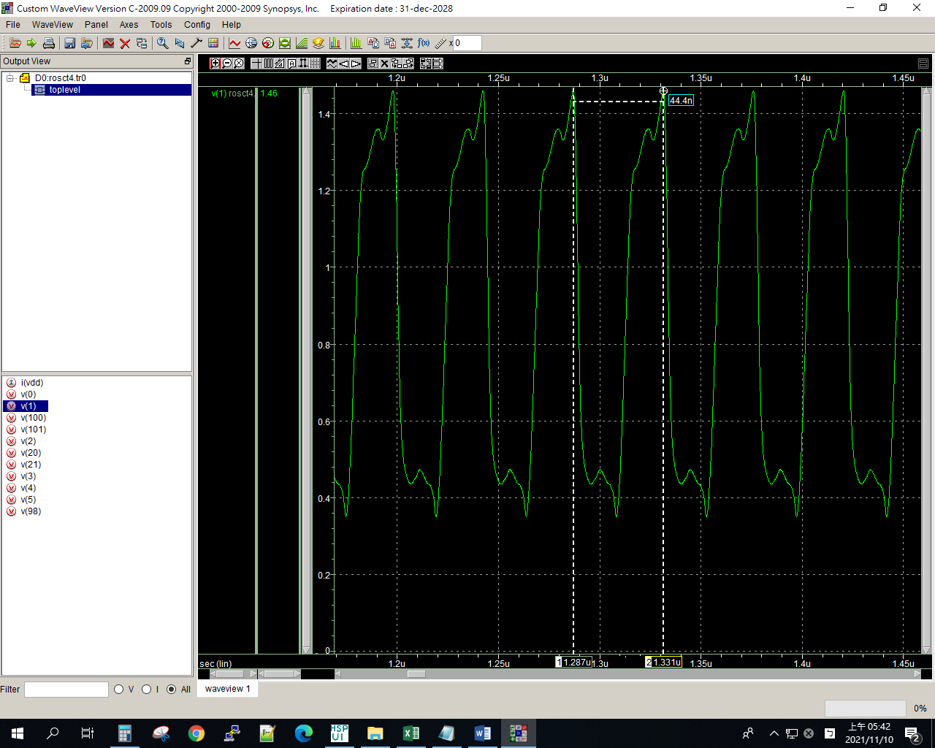

6u

ROSCT

.lib "C:\synopsys\cic018.l" tt

.SUBCKT INV 10 20 100 99

M1 20 10 100 100 P_18 W=2U L=2U

M2 20 10 99 99 N_18 W=1U L=2U

.ENDS INV

.SUBCKT NAND A B Y 100 99

M1 Y A 100 100 P_18 W=1u L=2u

M2 Y B 100 100 P_18 W=1u L=2u

M3 Y B 1 99 N_18 W=2u L=2u

M4 1 A 99 99 N_18 W=2u L=2u

.ENDS NAND

.SUBCKT NOR A B Y 100 99

M1 1 A 100 100 P_18 W=2u L=2u

M2 Y B 1 100 P_18 W=2u L=2u

M3 Y A 99 99 N_18 W=1u L=2u

M4 Y B 99 99 N_18 W=1u L=2u

.ENDS NOR

Vdd 100 0 dc PWL(0 0 1us 0 1.1us 1.8v 2us 1.8v)

X1 1 2 101 98 INV

X2 2 3 101 98 INV

X3 3 4 101 98 INV

X4 4 5 101 98 INV

X5 5 1 101 98 INV

Mx1 20 20 100 100 P_18 W=2u L=0.2u

Mx2 21 21 0 0 N_18 W=1u L=0.2u

Mx3 101 20 100 100 P_18 W=2u L=0.2u

Mx4 98 21 0 0 N_18 W=1u L=0.2u

Ix1 20 21 DC 6uA

*X1 1 1 2 100 0 NAND

*X2 2 2 3 100 0 NAND

*X3 3 3 4 100 0 NAND

*X4 4 4 5 100 0 NAND

*X5 5 5 1 100 0 NAND

*X1 1 1 2 100 0 NOR

*X2 2 2 3 100 0 NOR

*X3 3 3 4 100 0 NOR

*X4 4 4 5 100 0 NOR

*X5 5 5 1 100 0 NOR

**analysis

.op

.option post

.tran 1ps 10us 0 0.1ns

.probe

.end

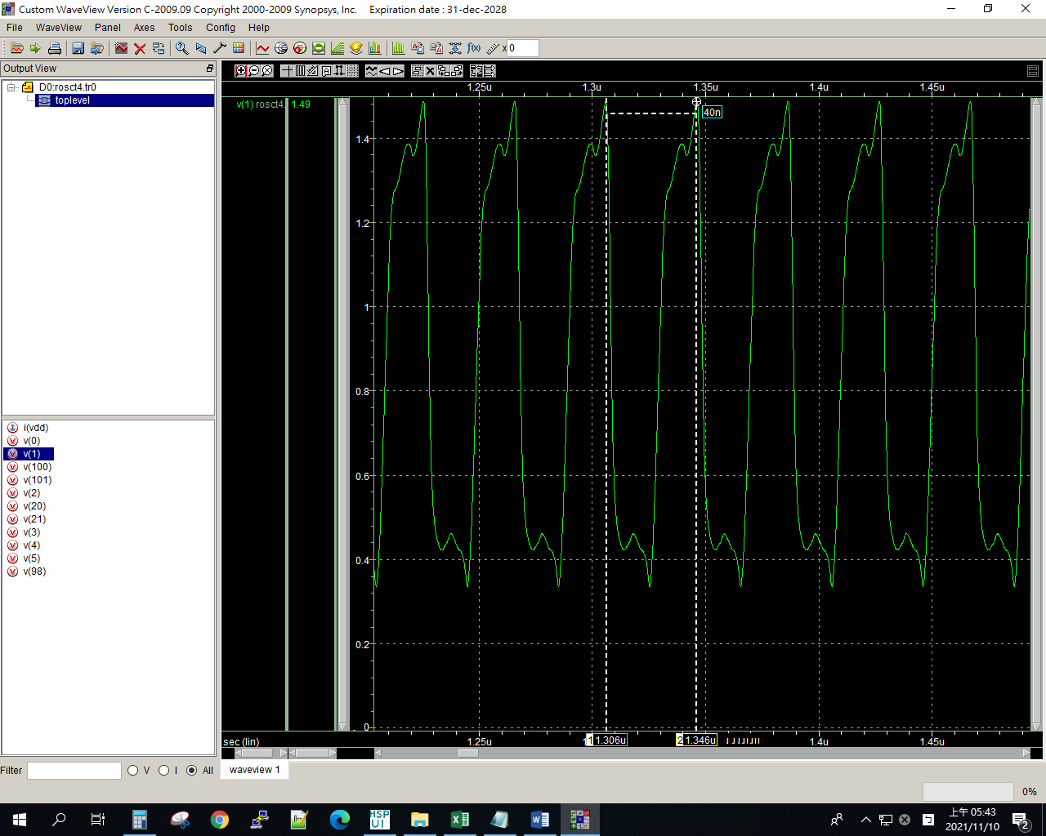

7u

ROSCT

.lib "C:\synopsys\cic018.l" tt

.SUBCKT INV 10 20 100 99

M1 20 10 100 100 P_18 W=2U L=2U

M2 20 10 99 99 N_18 W=1U L=2U

.ENDS INV

.SUBCKT NAND A B Y 100 99

M1 Y A 100 100 P_18 W=1u L=2u

M2 Y B 100 100 P_18 W=1u L=2u

M3 Y B 1 99 N_18 W=2u L=2u

M4 1 A 99 99 N_18 W=2u L=2u

.ENDS NAND

.SUBCKT NOR A B Y 100 99

M1 1 A 100 100 P_18 W=2u L=2u

M2 Y B 1 100 P_18 W=2u L=2u

M3 Y A 99 99 N_18 W=1u L=2u

M4 Y B 99 99 N_18 W=1u L=2u

.ENDS NOR

Vdd 100 0 dc PWL(0 0 1us 0 1.1us 1.8v 2us 1.8v)

X1 1 2 101 98 INV

X2 2 3 101 98 INV

X3 3 4 101 98 INV

X4 4 5 101 98 INV

X5 5 1 101 98 INV

Mx1 20 20 100 100 P_18 W=2u L=0.2u

Mx2 21 21 0 0 N_18 W=1u L=0.2u

Mx3 101 20 100 100 P_18 W=2u L=0.2u

Mx4 98 21 0 0 N_18 W=1u L=0.2u

Ix1 20 21 DC 7uA

*X1 1 1 2 100 0 NAND

*X2 2 2 3 100 0 NAND

*X3 3 3 4 100 0 NAND

*X4 4 4 5 100 0 NAND

*X5 5 5 1 100 0 NAND

*X1 1 1 2 100 0 NOR

*X2 2 2 3 100 0 NOR

*X3 3 3 4 100 0 NOR

*X4 4 4 5 100 0 NOR

*X5 5 5 1 100 0 NOR

**analysis

.op

.option post

.tran 1ps 10us 0 0.1ns

.probe

.end

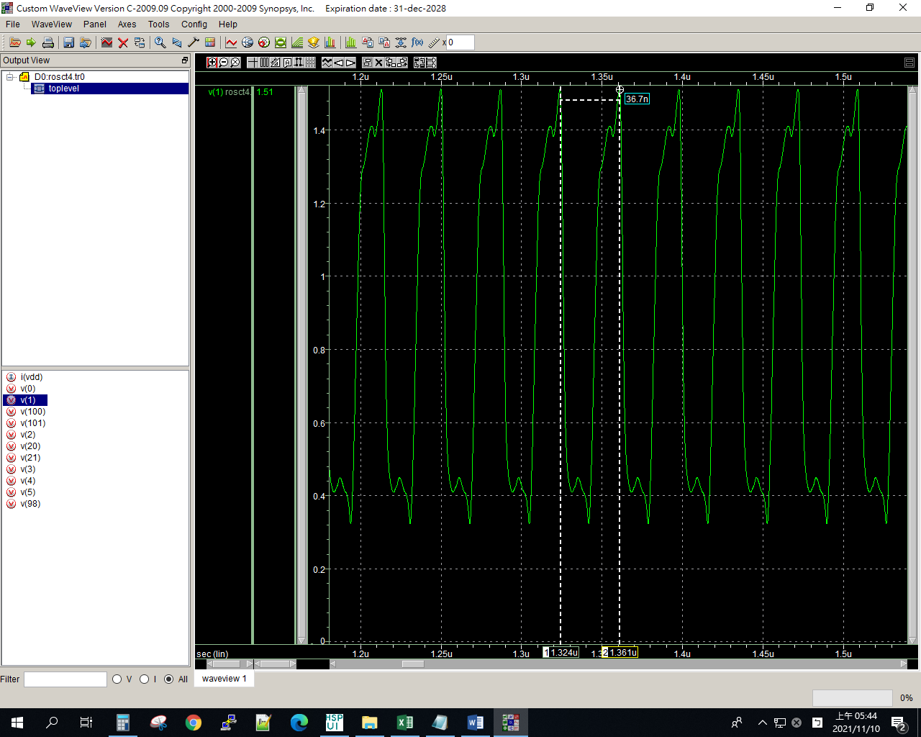

8u

ROSCT

.lib "C:\synopsys\cic018.l" tt

.SUBCKT INV 10 20 100 99

M1 20 10 100 100 P_18 W=2U L=2U

M2 20 10 99 99 N_18 W=1U L=2U

.ENDS INV

.SUBCKT NAND A B Y 100 99

M1 Y A 100 100 P_18 W=1u L=2u

M2 Y B 100 100 P_18 W=1u L=2u

M3 Y B 1 99 N_18 W=2u L=2u

M4 1 A 99 99 N_18 W=2u L=2u

.ENDS NAND

.SUBCKT NOR A B Y 100 99

M1 1 A 100 100 P_18 W=2u L=2u

M2 Y B 1 100 P_18 W=2u L=2u

M3 Y A 99 99 N_18 W=1u L=2u

M4 Y B 99 99 N_18 W=1u L=2u

.ENDS NOR

Vdd 100 0 dc PWL(0 0 1us 0 1.1us 1.8v 2us 1.8v)

X1 1 2 101 98 INV

X2 2 3 101 98 INV

X3 3 4 101 98 INV

X4 4 5 101 98 INV

X5 5 1 101 98 INV

Mx1 20 20 100 100 P_18 W=2u L=0.2u

Mx2 21 21 0 0 N_18 W=1u L=0.2u

Mx3 101 20 100 100 P_18 W=2u L=0.2u

Mx4 98 21 0 0 N_18 W=1u L=0.2u

Ix1 20 21 DC 8uA

*X1 1 1 2 100 0 NAND

*X2 2 2 3 100 0 NAND

*X3 3 3 4 100 0 NAND

*X4 4 4 5 100 0 NAND

*X5 5 5 1 100 0 NAND

*X1 1 1 2 100 0 NOR

*X2 2 2 3 100 0 NOR

*X3 3 3 4 100 0 NOR

*X4 4 4 5 100 0 NOR

*X5 5 5 1 100 0 NOR

**analysis

.op

.option post

.tran 1ps 10us 0 0.1ns

.probe

.end

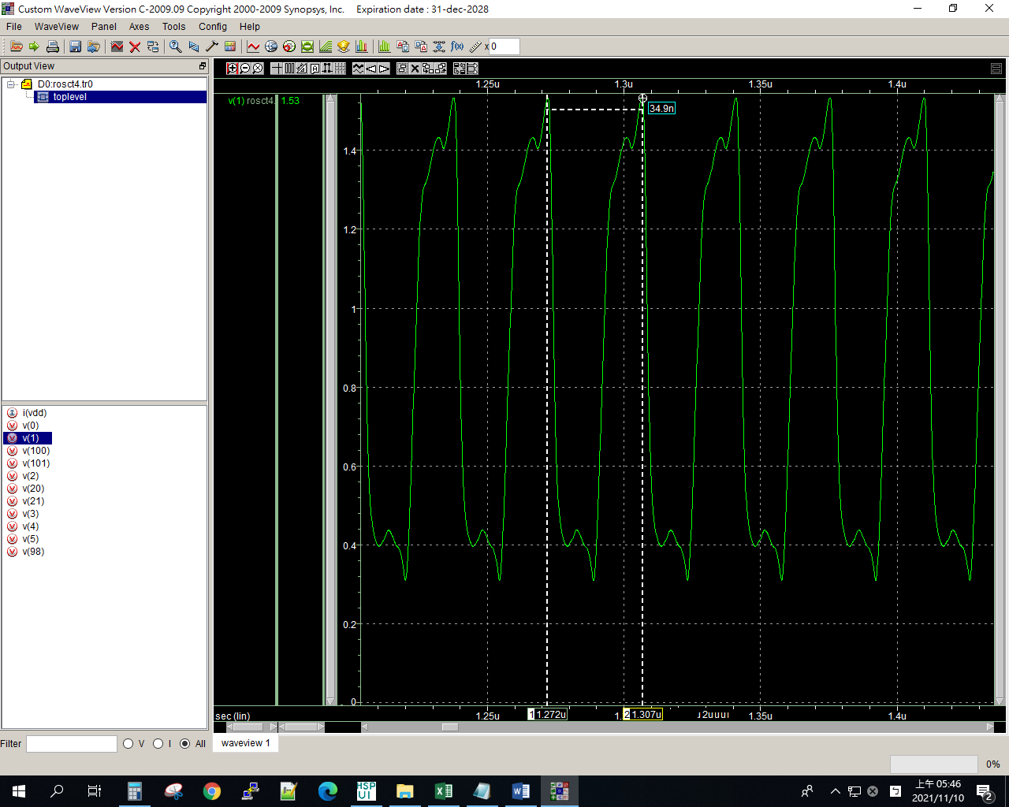

9u

ROSCT

.lib "C:\synopsys\cic018.l" tt

.SUBCKT INV 10 20 100 99

M1 20 10 100 100 P_18 W=2U L=2U

M2 20 10 99 99 N_18 W=1U L=2U

.ENDS INV

.SUBCKT NAND A B Y 100 99

M1 Y A 100 100 P_18 W=1u L=2u

M2 Y B 100 100 P_18 W=1u L=2u

M3 Y B 1 99 N_18 W=2u L=2u

M4 1 A 99 99 N_18 W=2u L=2u

.ENDS NAND

.SUBCKT NOR A B Y 100 99

M1 1 A 100 100 P_18 W=2u L=2u

M2 Y B 1 100 P_18 W=2u L=2u

M3 Y A 99 99 N_18 W=1u L=2u

M4 Y B 99 99 N_18 W=1u L=2u

.ENDS NOR

Vdd 100 0 dc PWL(0 0 1us 0 1.1us 1.8v 2us 1.8v)

X1 1 2 101 98 INV

X2 2 3 101 98 INV

X3 3 4 101 98 INV

X4 4 5 101 98 INV

X5 5 1 101 98 INV

Mx1 20 20 100 100 P_18 W=2u L=0.2u

Mx2 21 21 0 0 N_18 W=1u L=0.2u

Mx3 101 20 100 100 P_18 W=2u L=0.2u

Mx4 98 21 0 0 N_18 W=1u L=0.2u

Ix1 20 21 DC 9uA

*X1 1 1 2 100 0 NAND

*X2 2 2 3 100 0 NAND

*X3 3 3 4 100 0 NAND

*X4 4 4 5 100 0 NAND

*X5 5 5 1 100 0 NAND

*X1 1 1 2 100 0 NOR

*X2 2 2 3 100 0 NOR

*X3 3 3 4 100 0 NOR

*X4 4 4 5 100 0 NOR

*X5 5 5 1 100 0 NOR

**analysis

.op

.option post

.tran 1ps 10us 0 0.1ns

.probe

.end

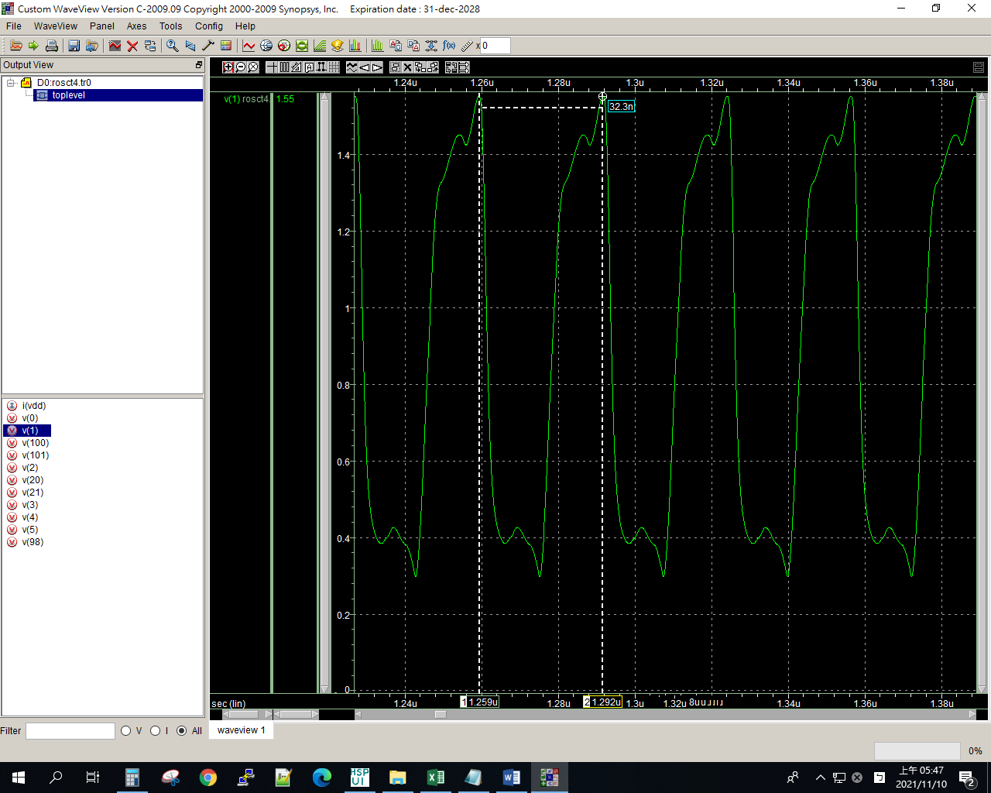

10u

ROSCT

.lib "C:\synopsys\cic018.l" tt

.SUBCKT INV 10 20 100 99

M1 20 10 100 100 P_18 W=2U L=2U

M2 20 10 99 99 N_18 W=1U L=2U

.ENDS INV

.SUBCKT NAND A B Y 100 99

M1 Y A 100 100 P_18 W=1u L=2u

M2 Y B 100 100 P_18 W=1u L=2u

M3 Y B 1 99 N_18 W=2u L=2u

M4 1 A 99 99 N_18 W=2u L=2u

.ENDS NAND

.SUBCKT NOR A B Y 100 99

M1 1 A 100 100 P_18 W=2u L=2u

M2 Y B 1 100 P_18 W=2u L=2u

M3 Y A 99 99 N_18 W=1u L=2u

M4 Y B 99 99 N_18 W=1u L=2u

.ENDS NOR

Vdd 100 0 dc PWL(0 0 1us 0 1.1us 1.8v 2us 1.8v)

X1 1 2 101 98 INV

X2 2 3 101 98 INV

X3 3 4 101 98 INV

X4 4 5 101 98 INV

X5 5 1 101 98 INV

Mx1 20 20 100 100 P_18 W=2u L=0.2u

Mx2 21 21 0 0 N_18 W=1u L=0.2u

Mx3 101 20 100 100 P_18 W=2u L=0.2u

Mx4 98 21 0 0 N_18 W=1u L=0.2u

Ix1 20 21 DC 10uA

*X1 1 1 2 100 0 NAND

*X2 2 2 3 100 0 NAND

*X3 3 3 4 100 0 NAND

*X4 4 4 5 100 0 NAND

*X5 5 5 1 100 0 NAND

*X1 1 1 2 100 0 NOR

*X2 2 2 3 100 0 NOR

*X3 3 3 4 100 0 NOR

*X4 4 4 5 100 0 NOR

*X5 5 5 1 100 0 NOR

**analysis

.op

.option post

.tran 1ps 10us 0 0.1ns

.probe

.end

